**Bismillahir Rahmanir Rahim**

**~~~~~~~~~~ Basic Java ~~~~~~~~~~**



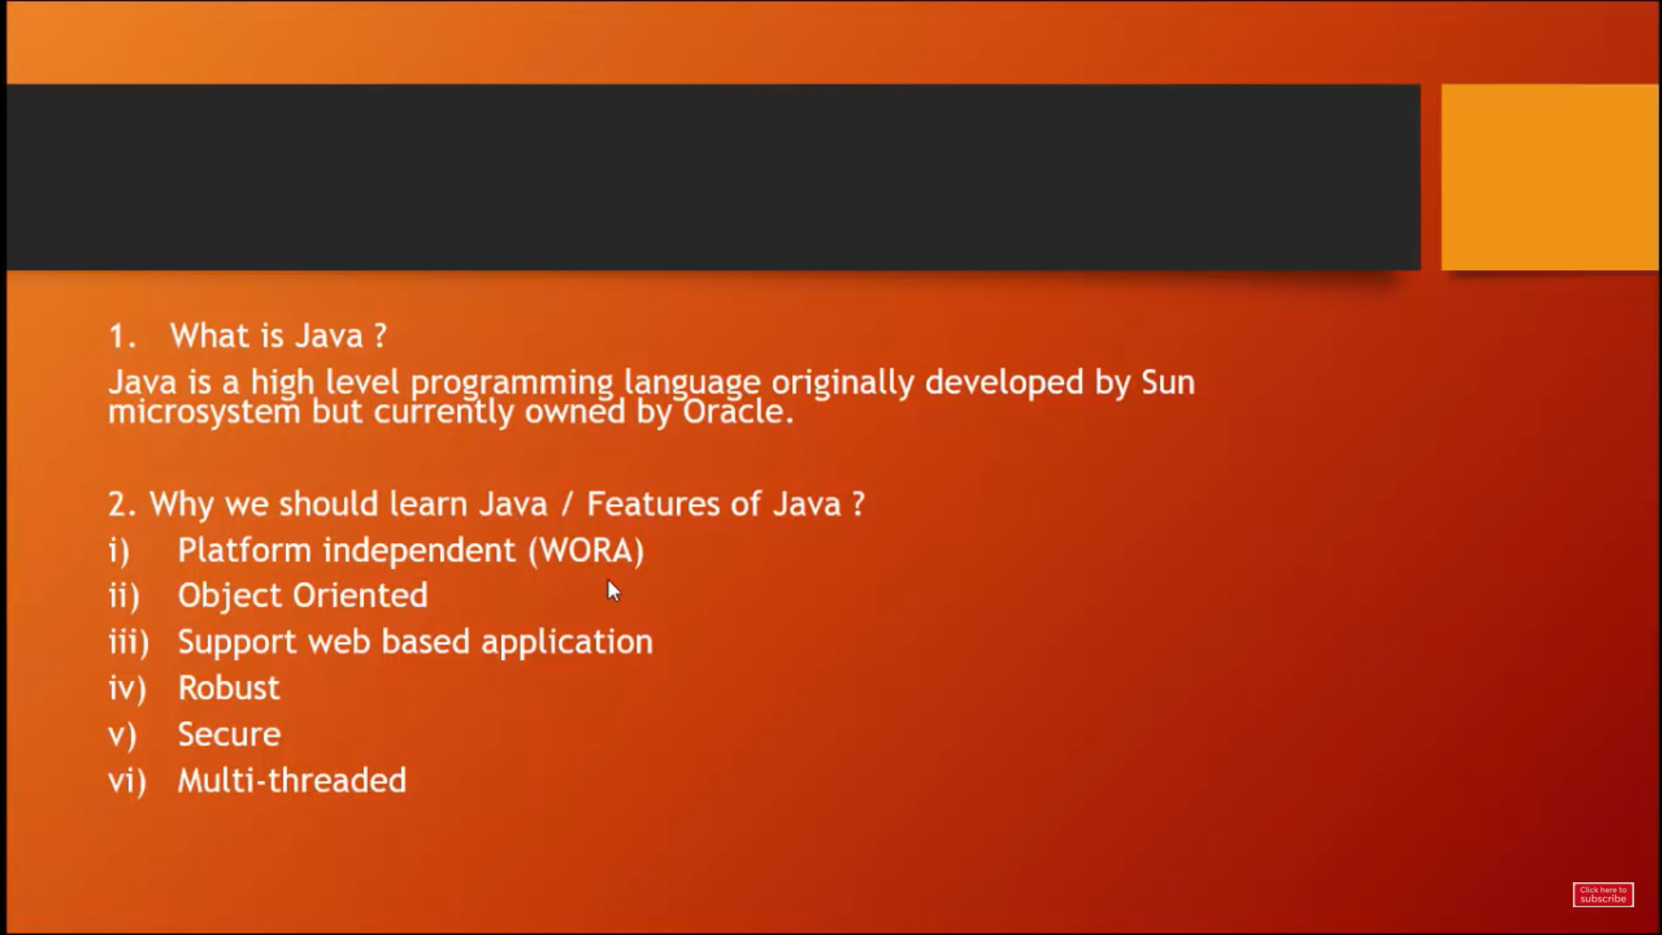

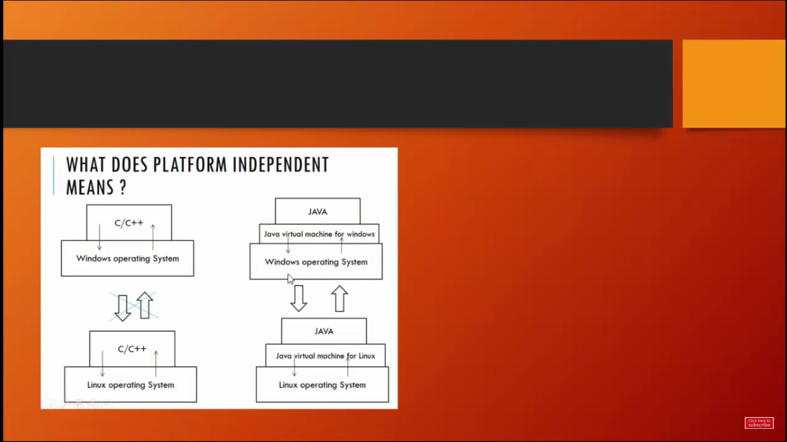

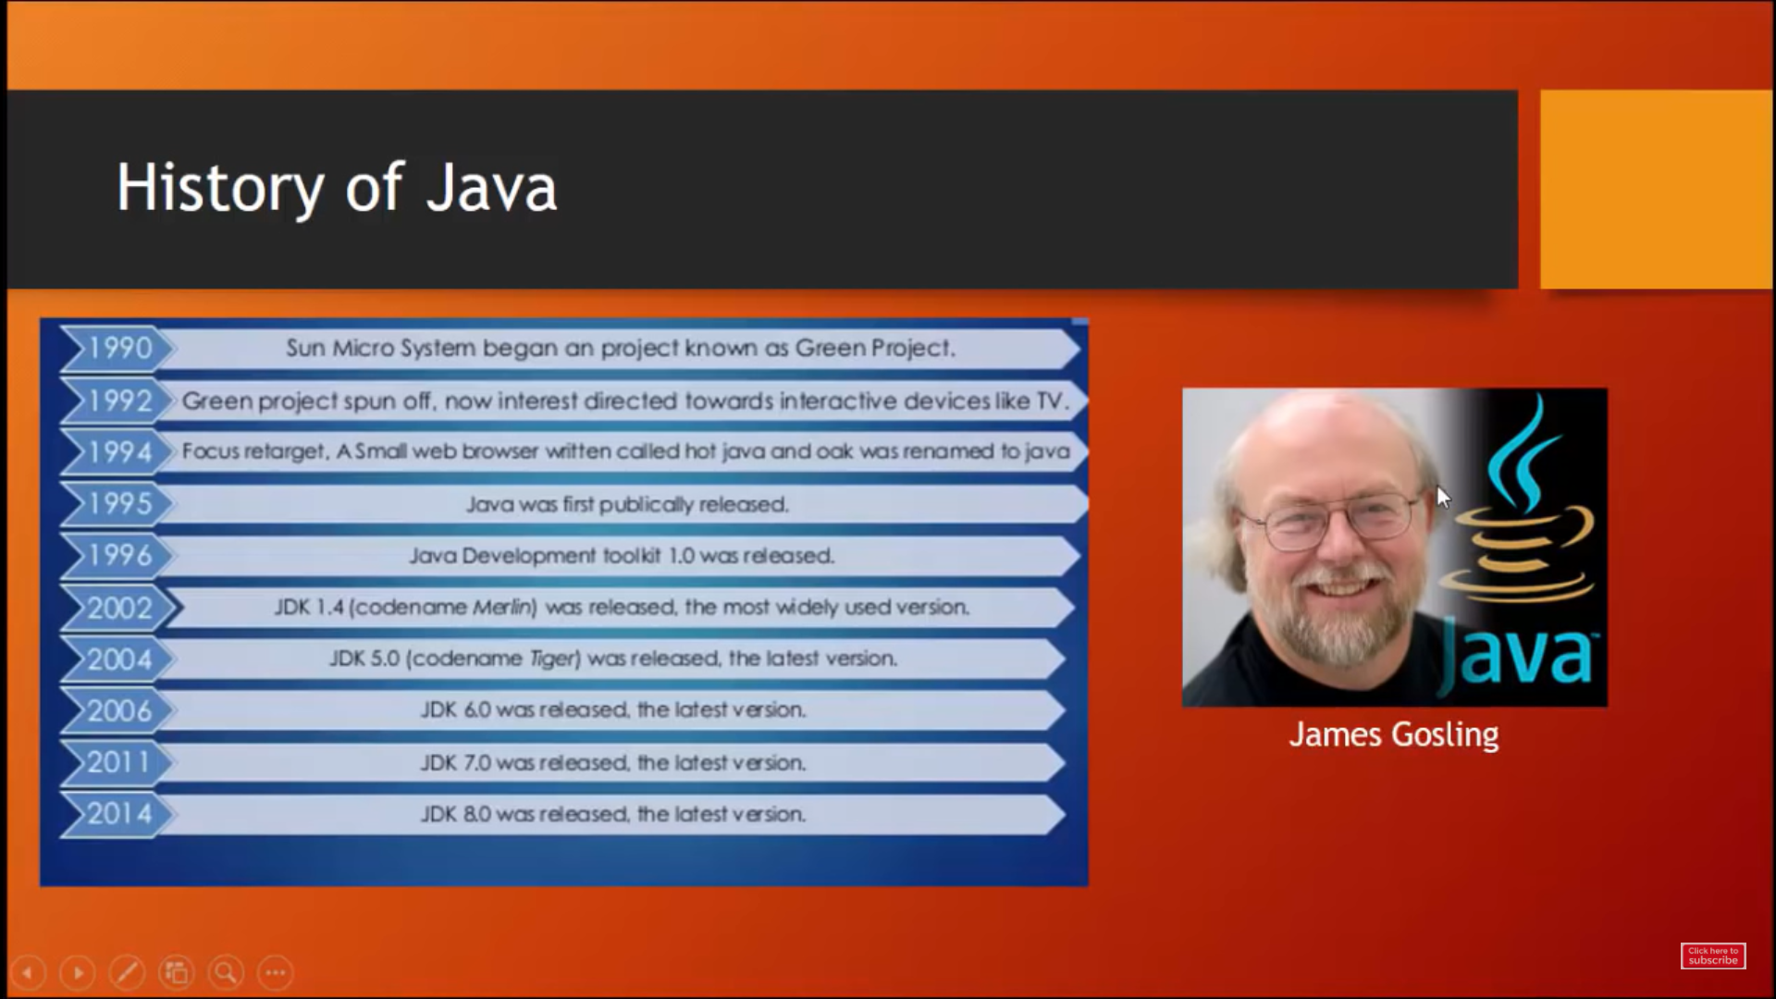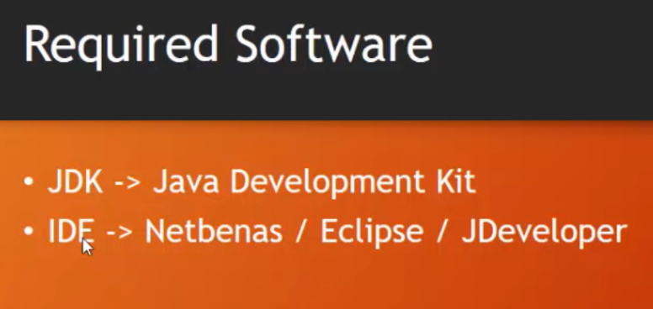

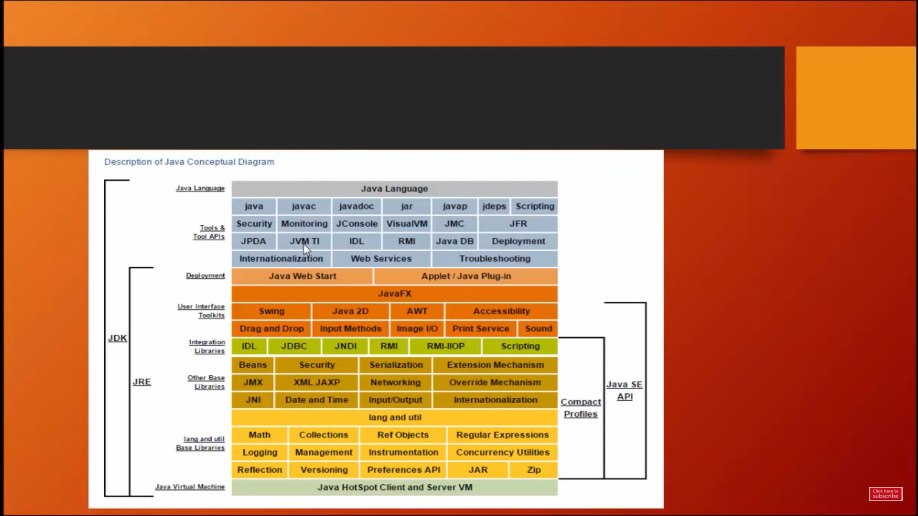

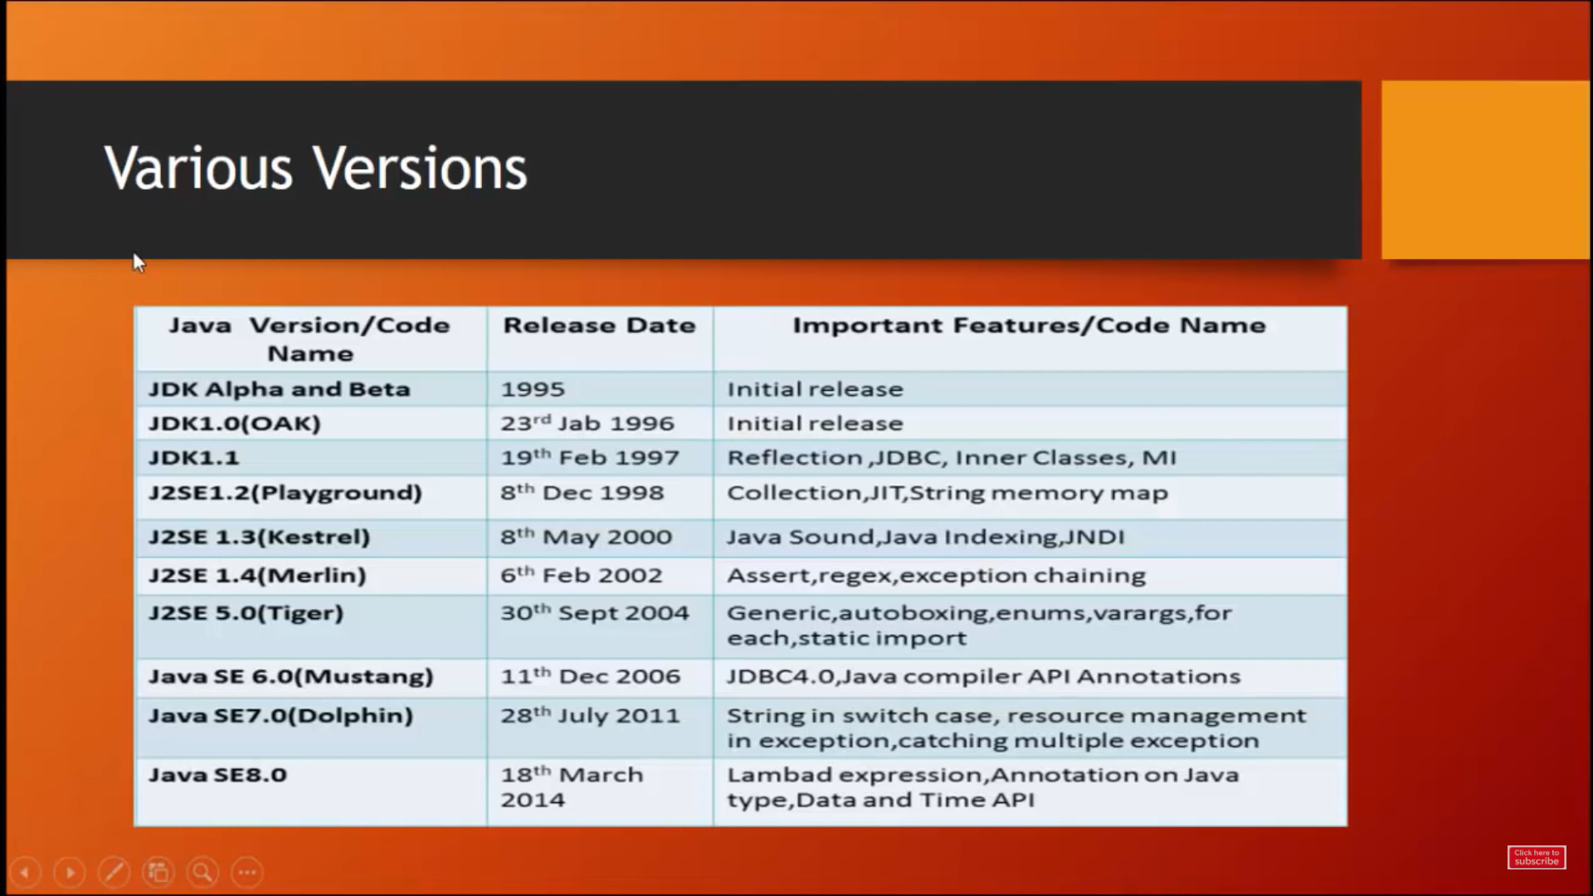

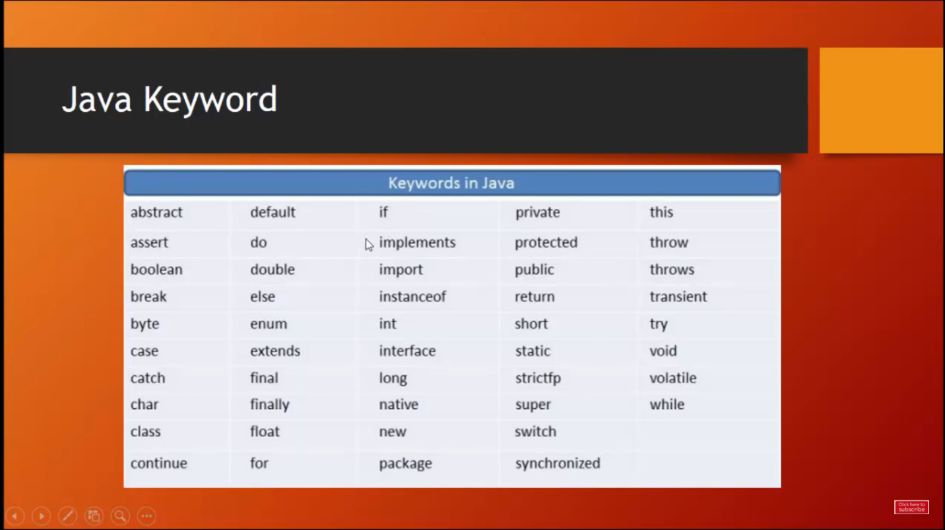

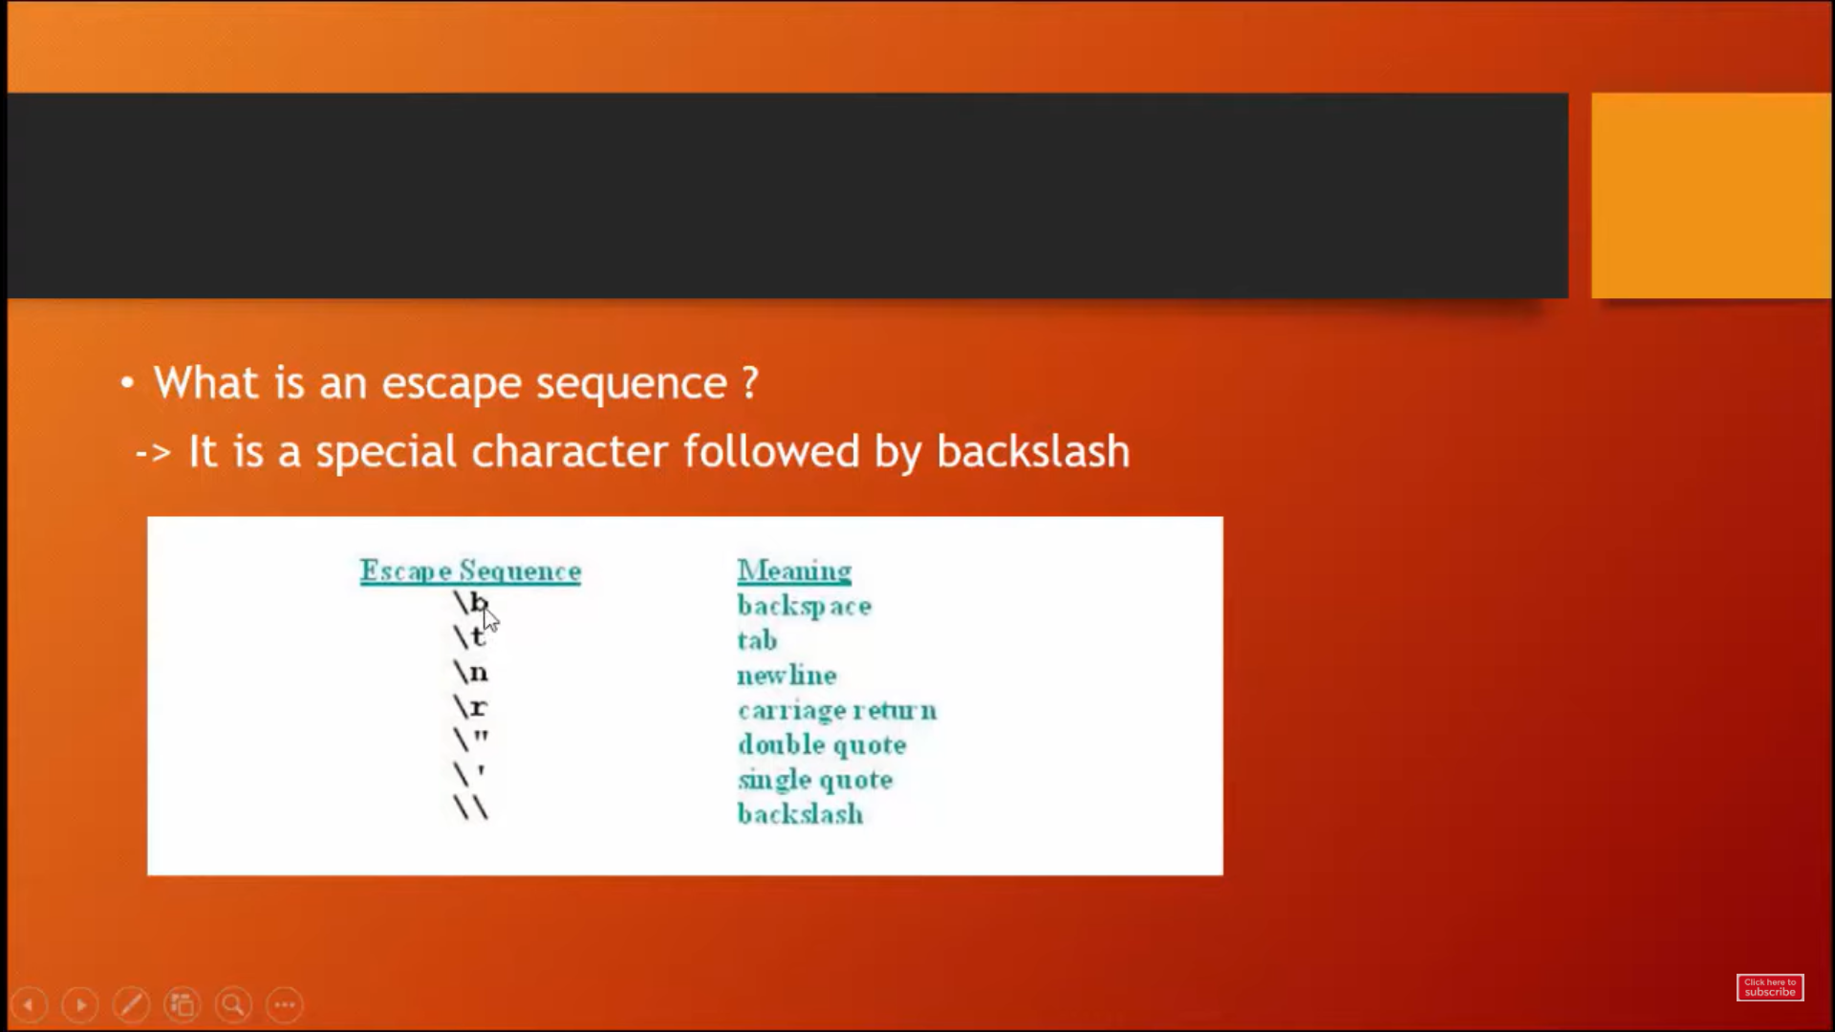

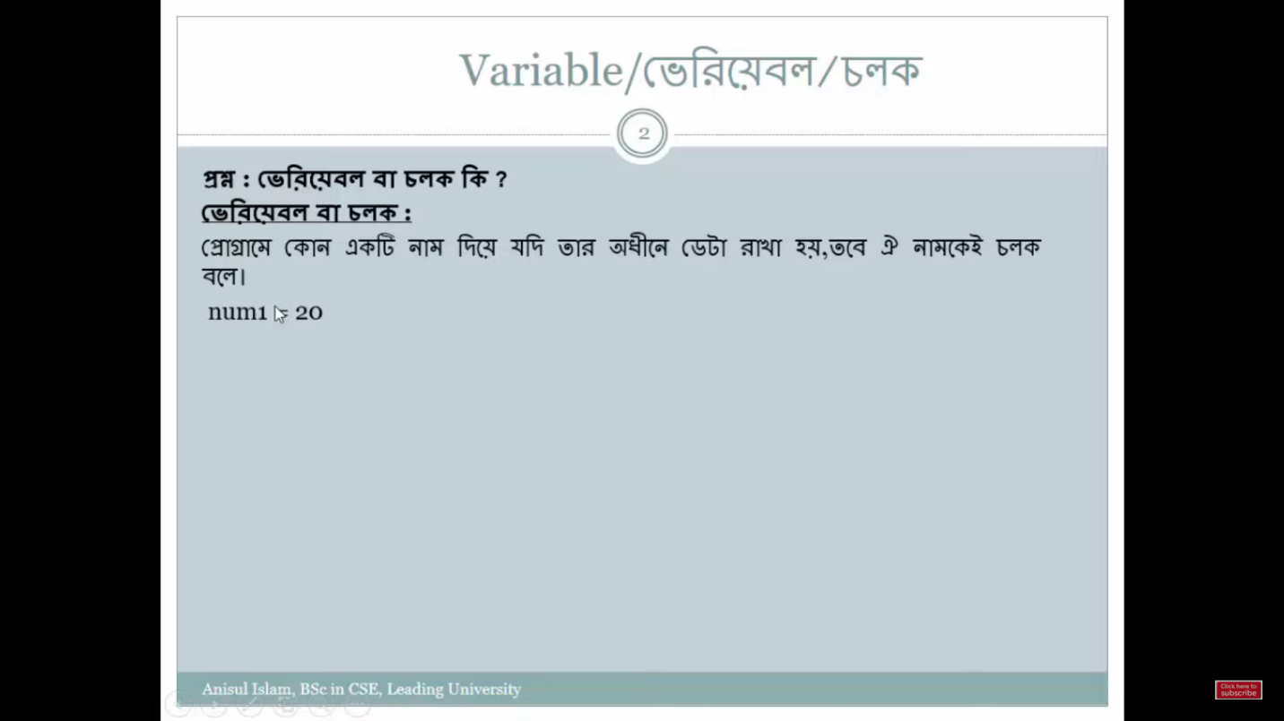

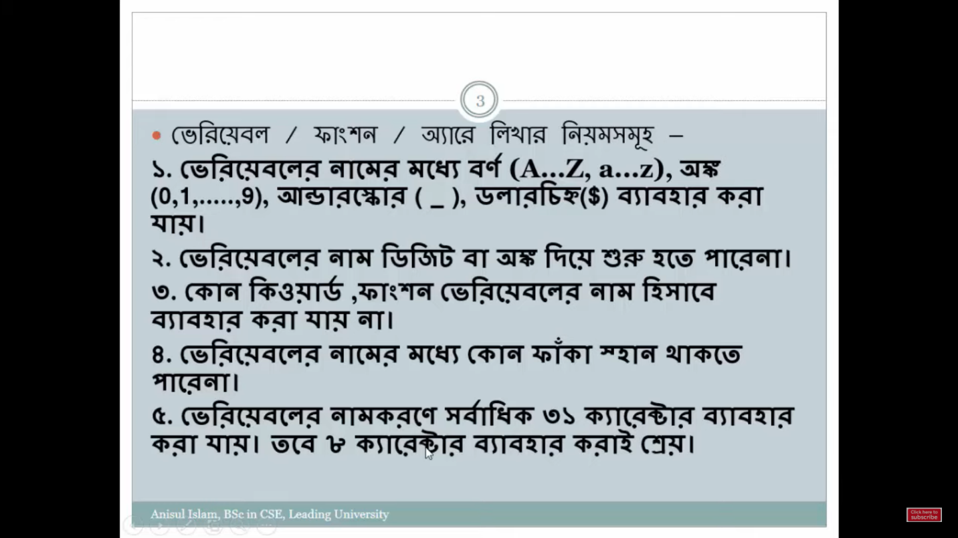

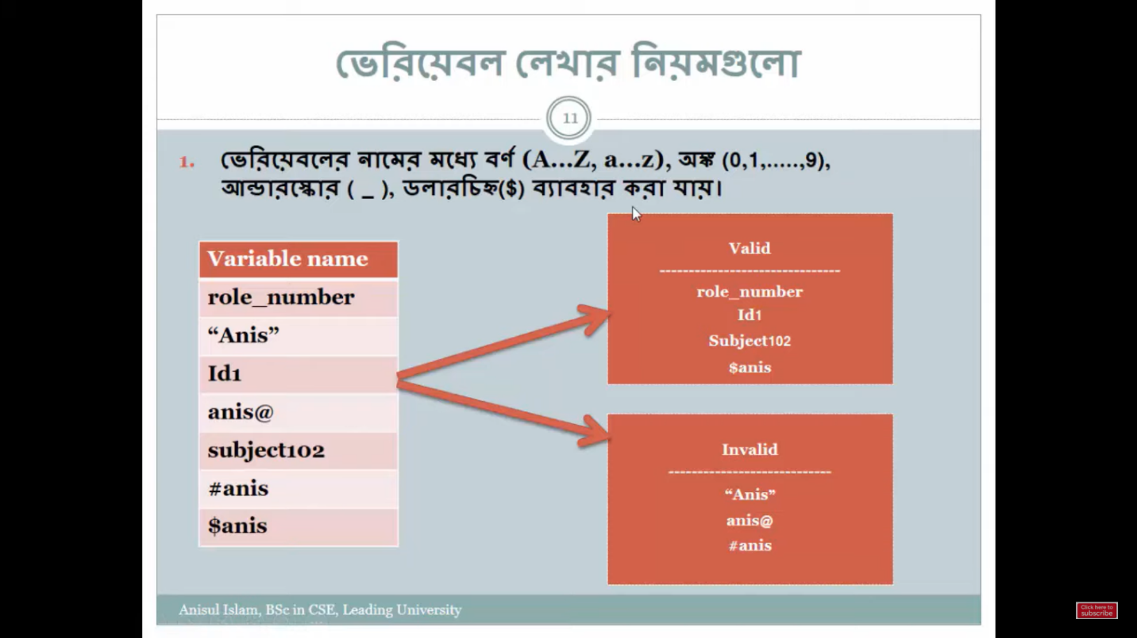

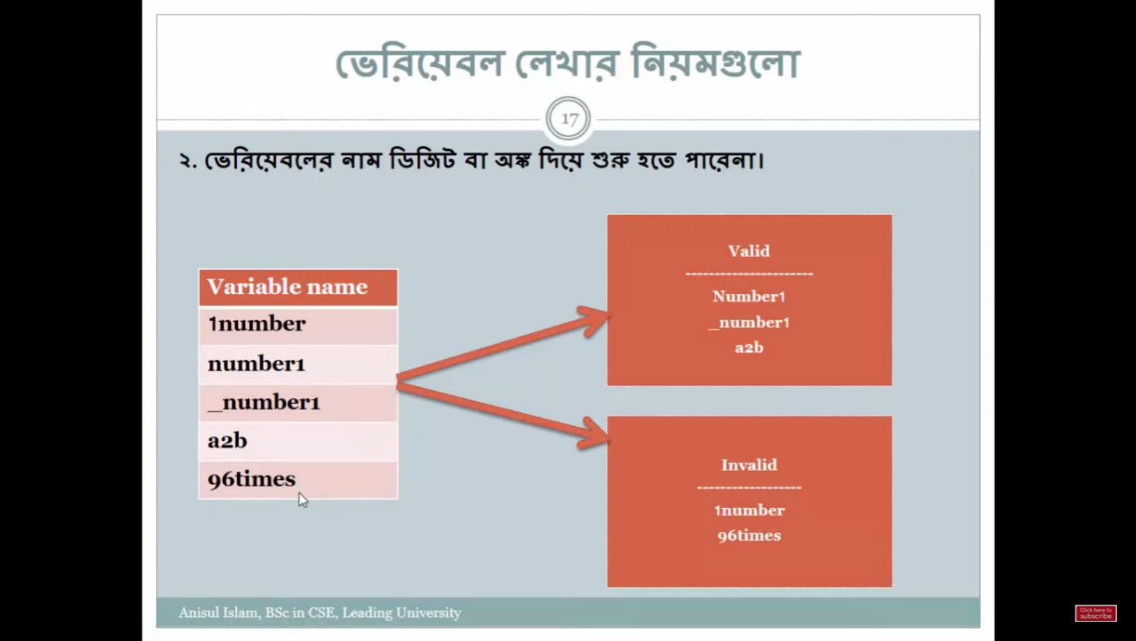

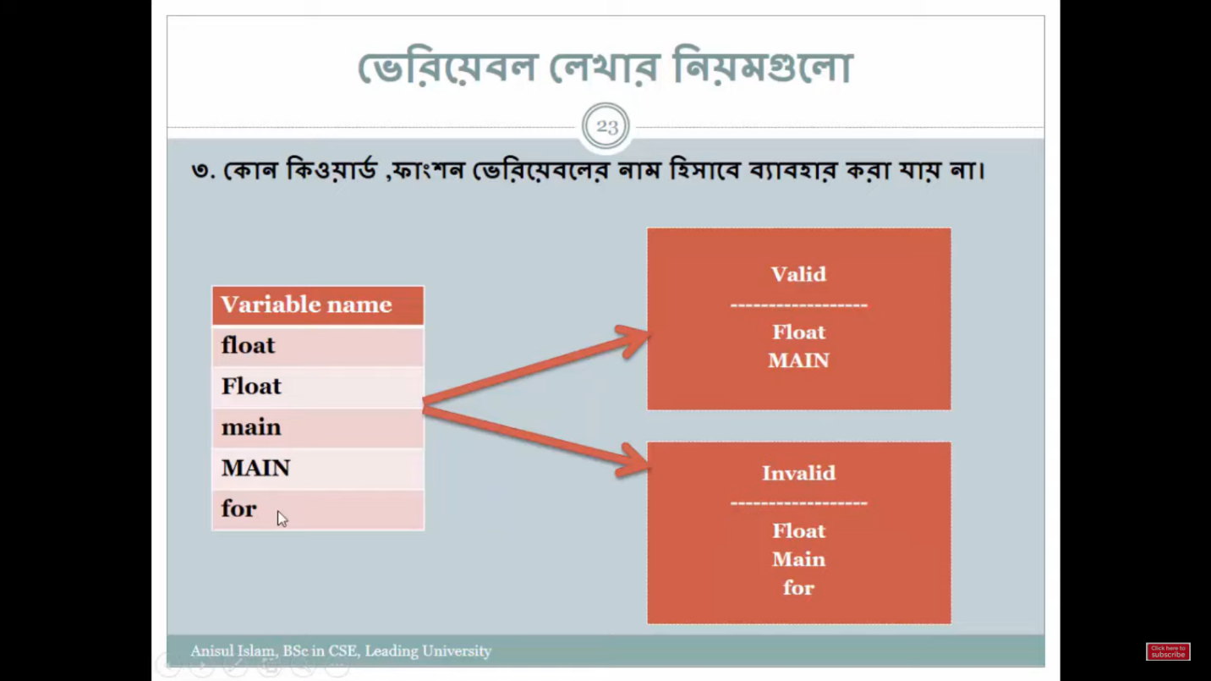

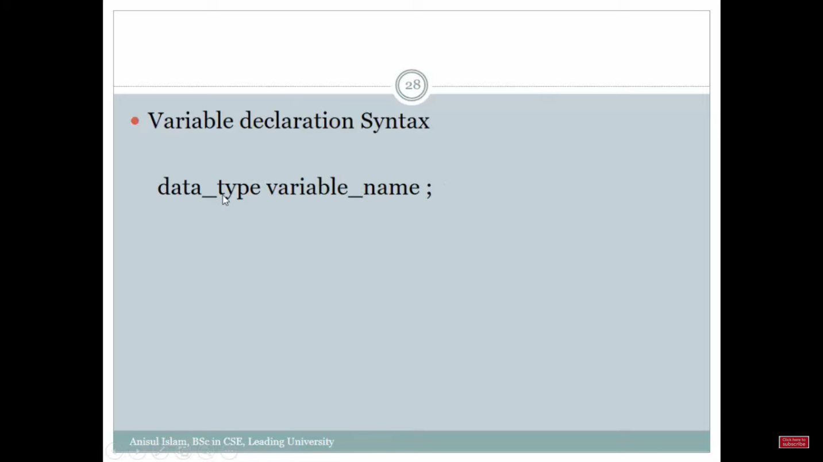

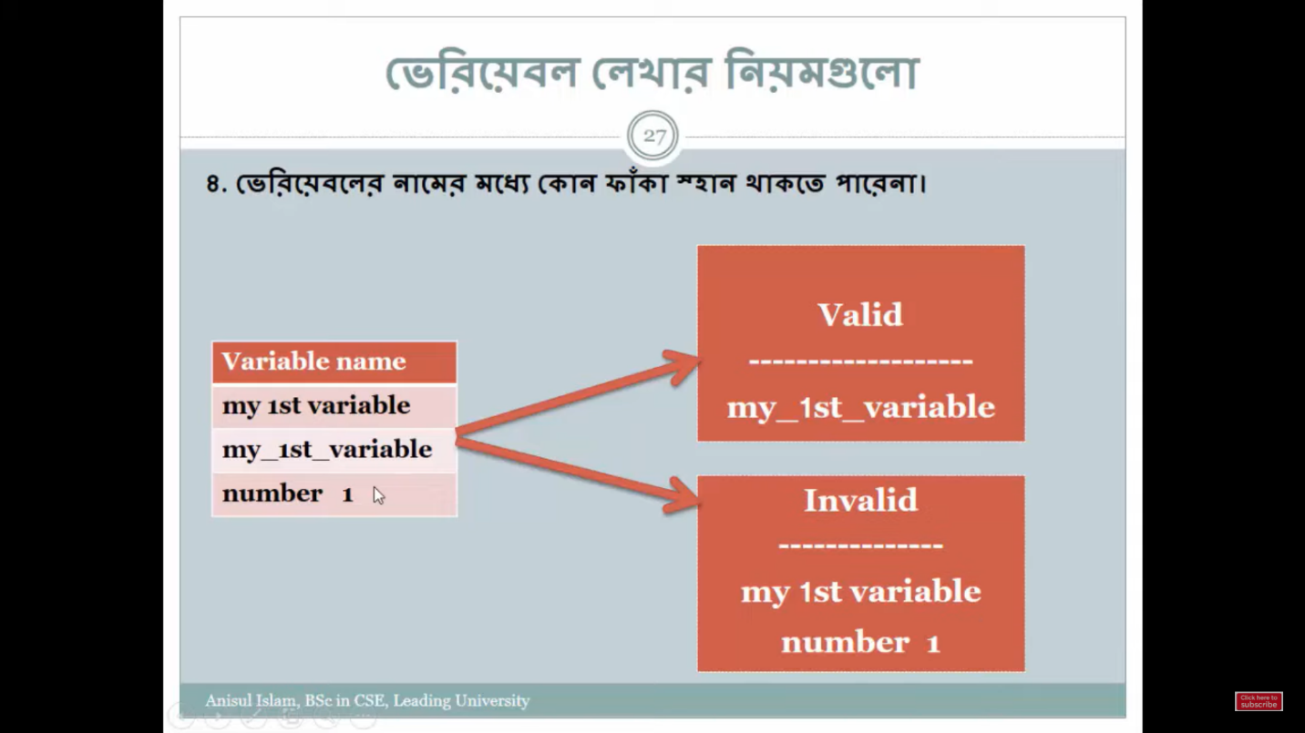

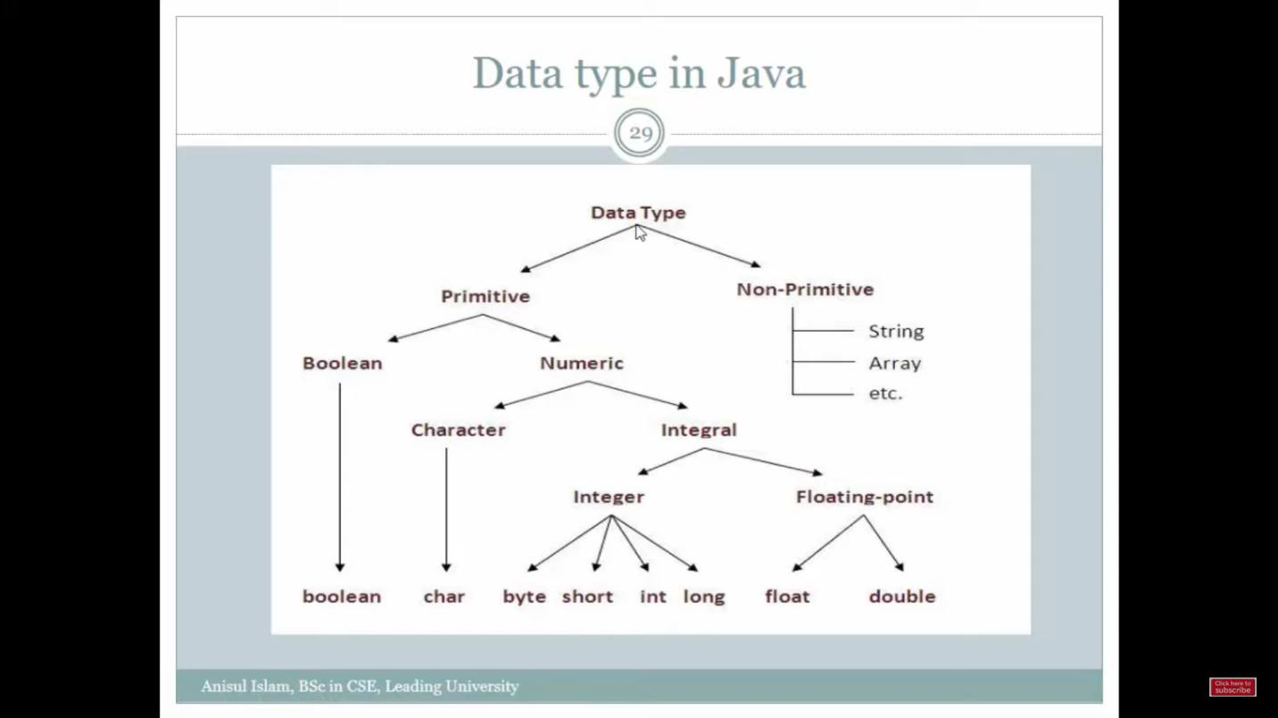

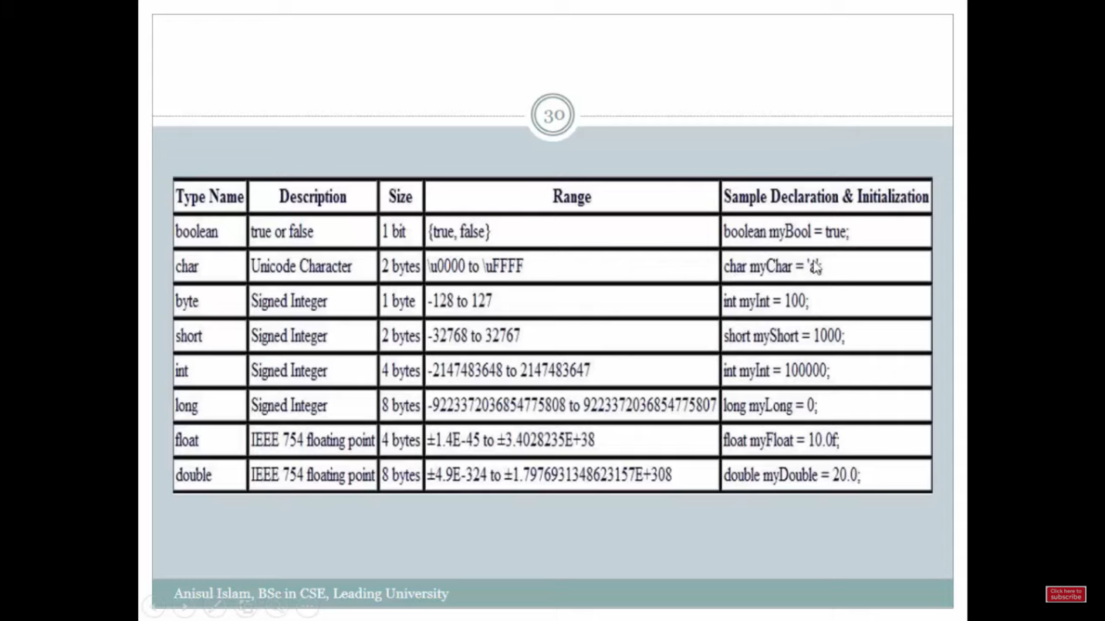

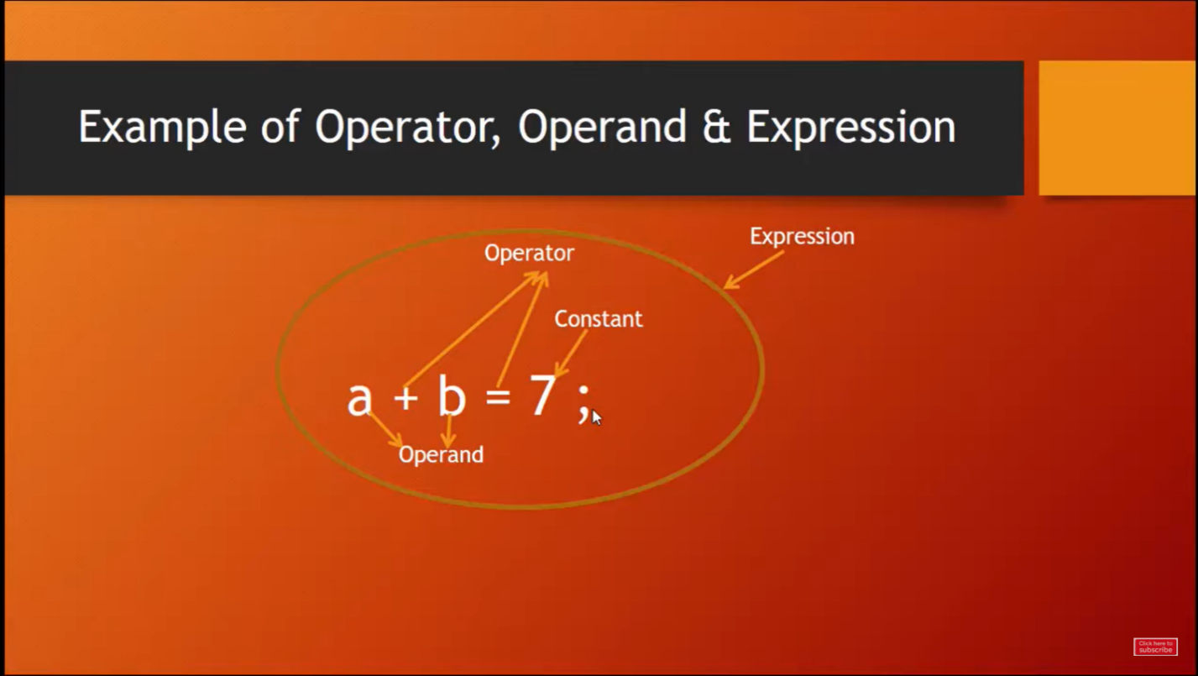

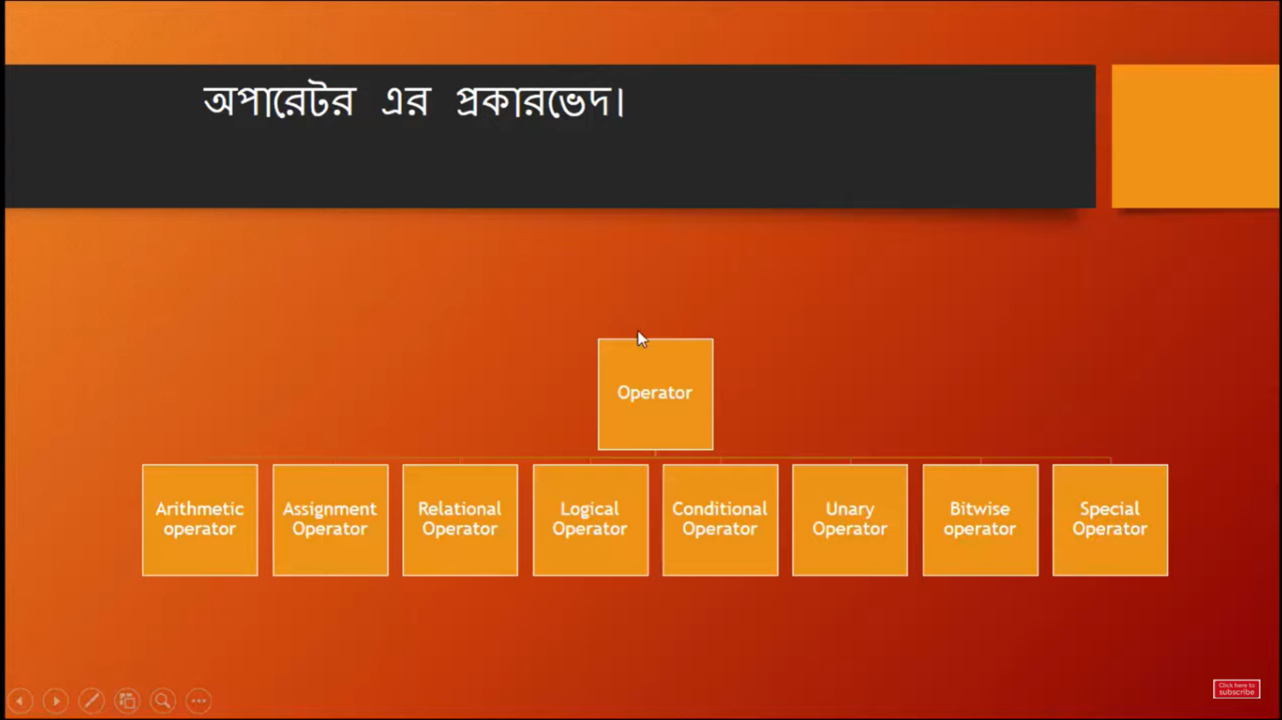

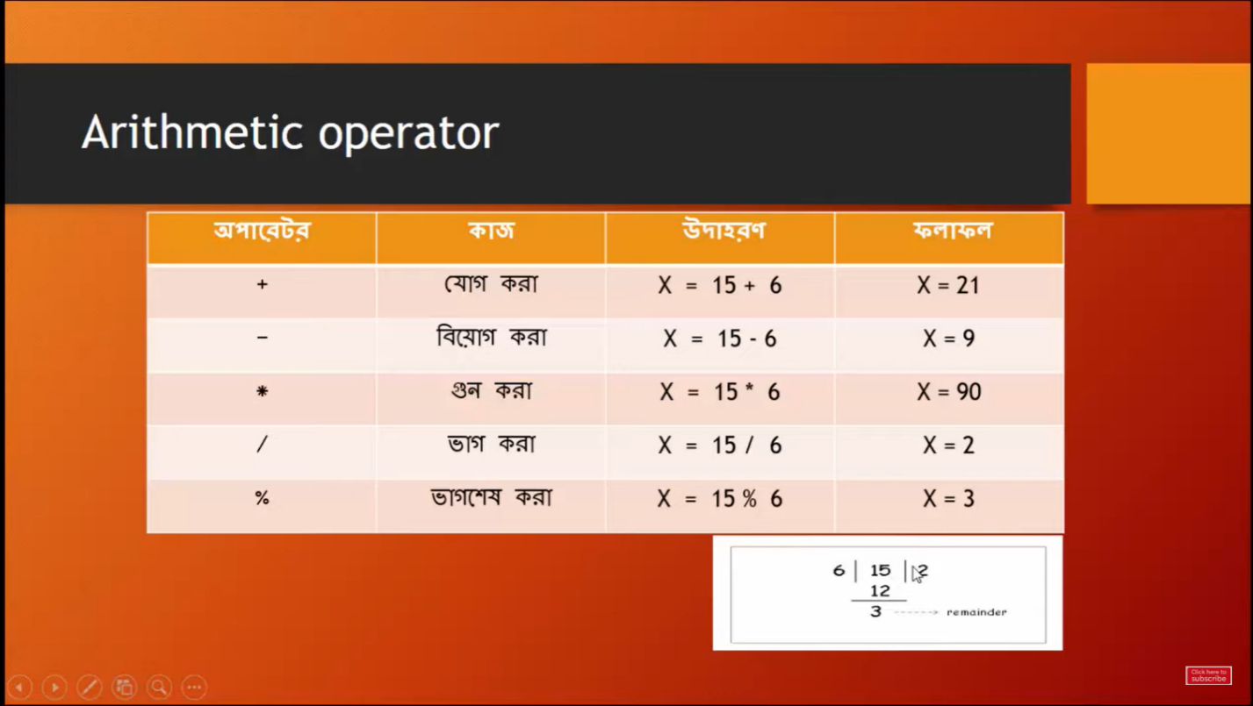

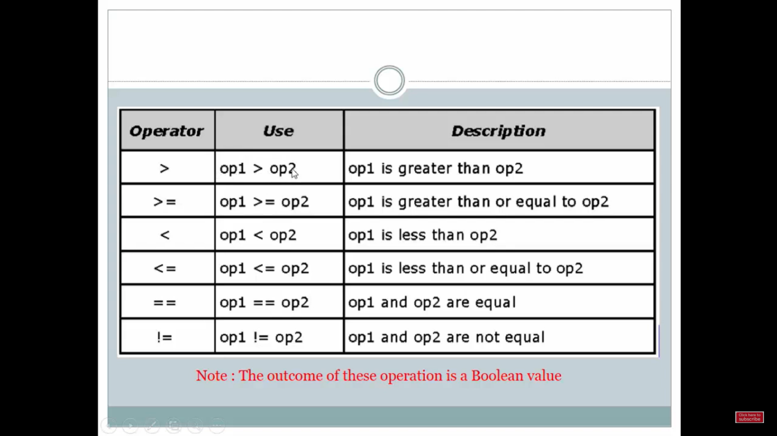

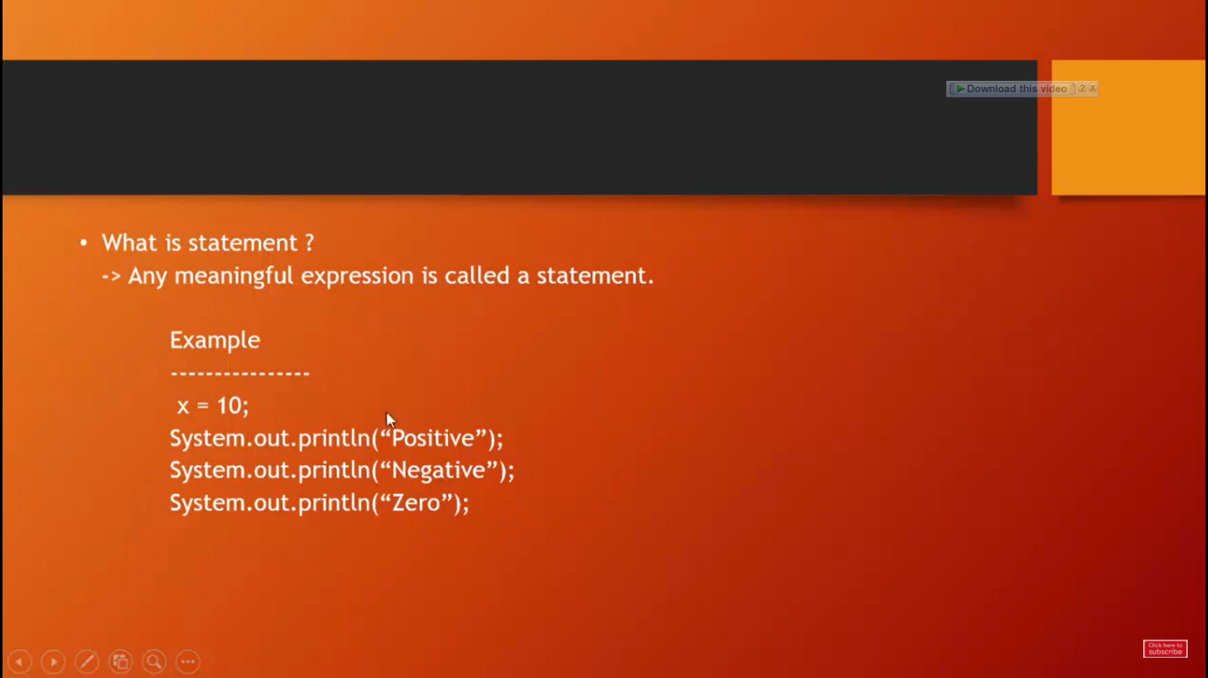

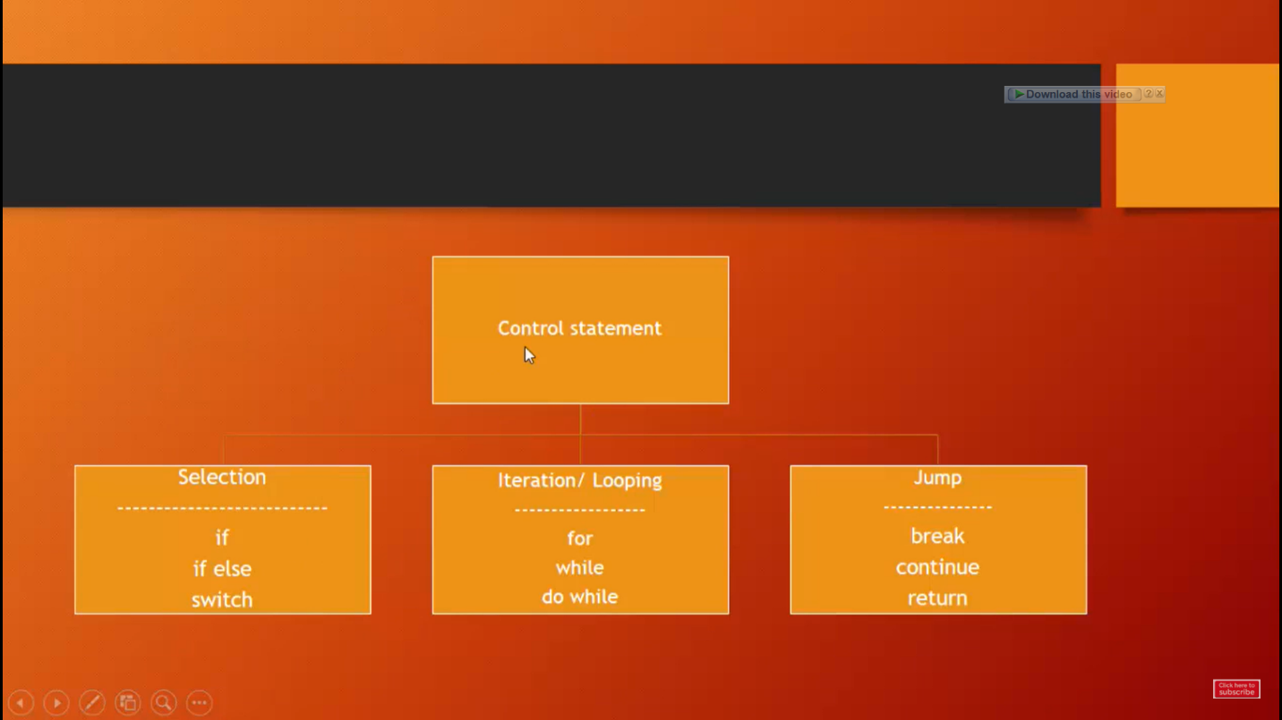

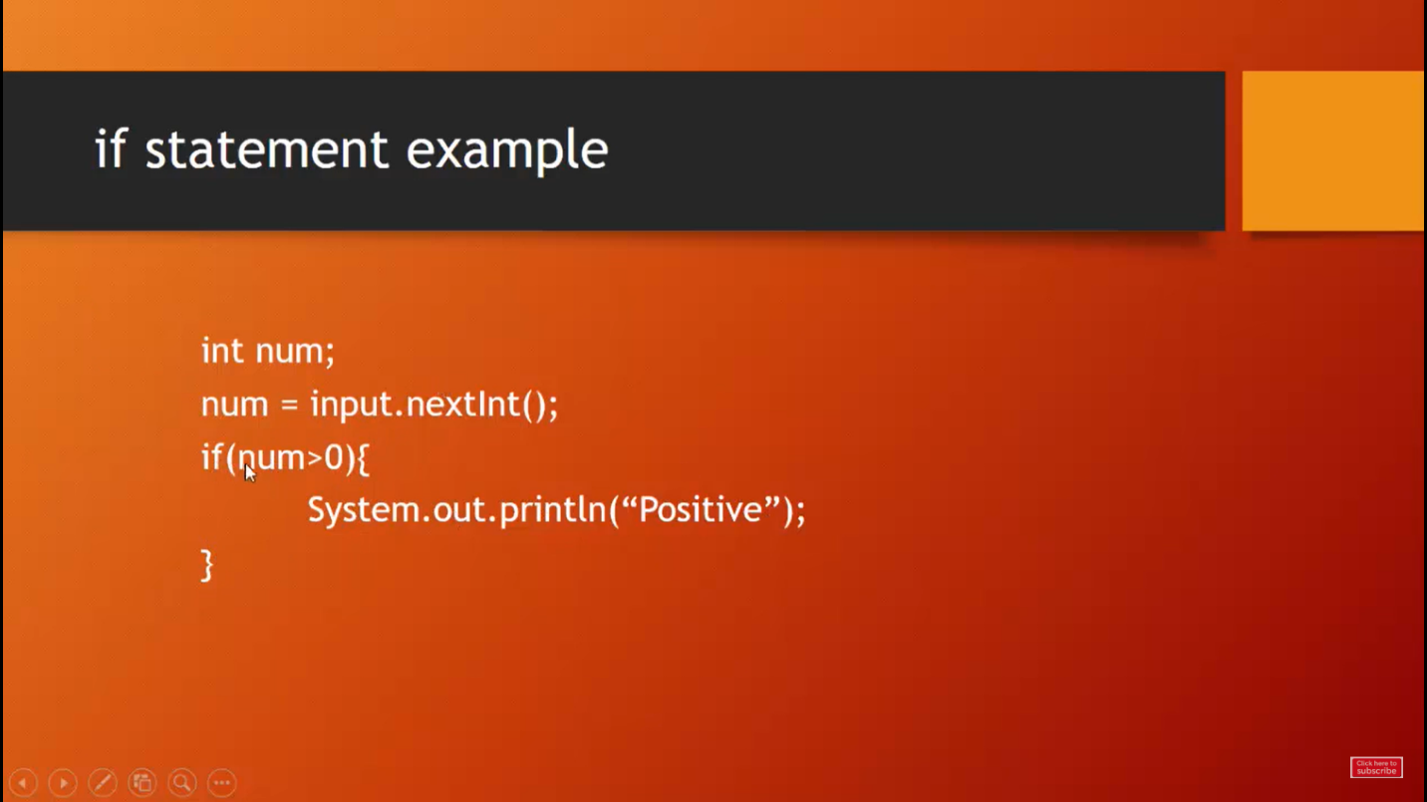

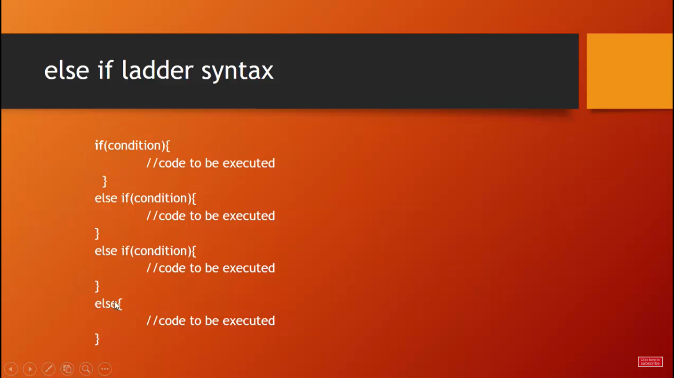

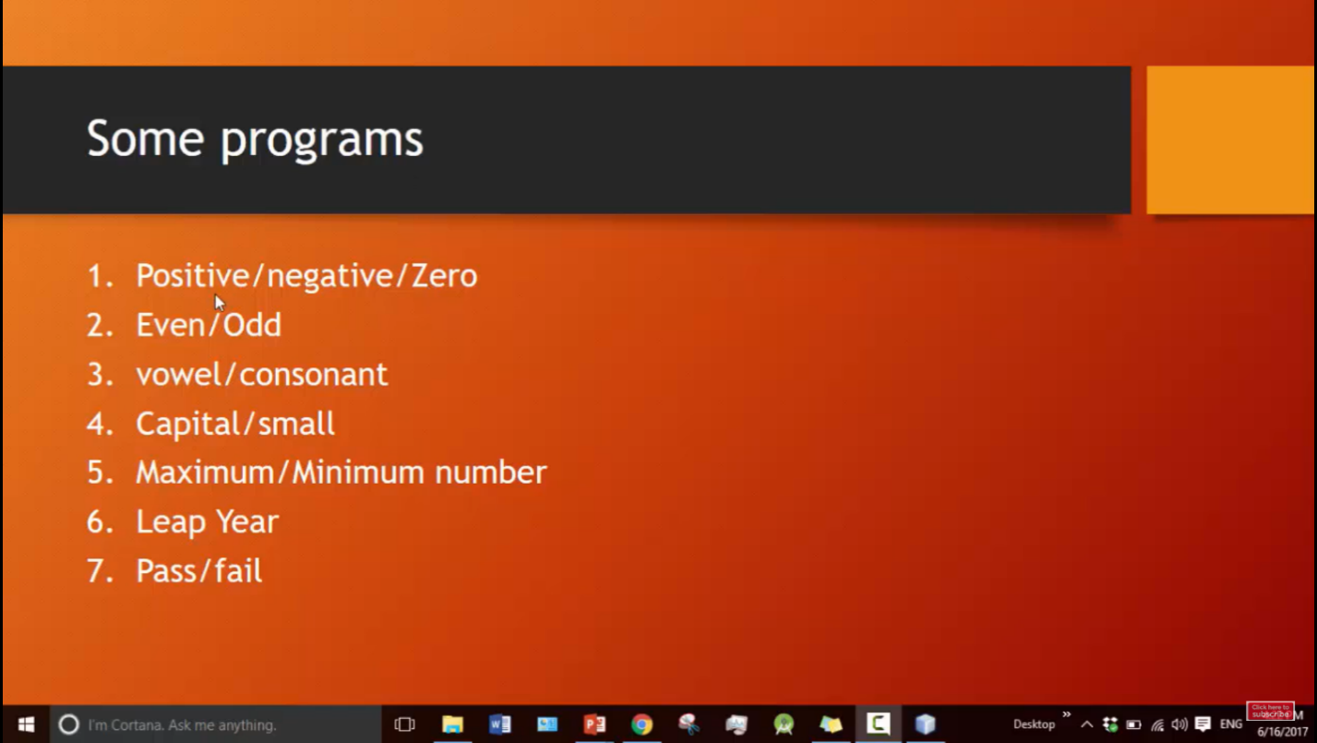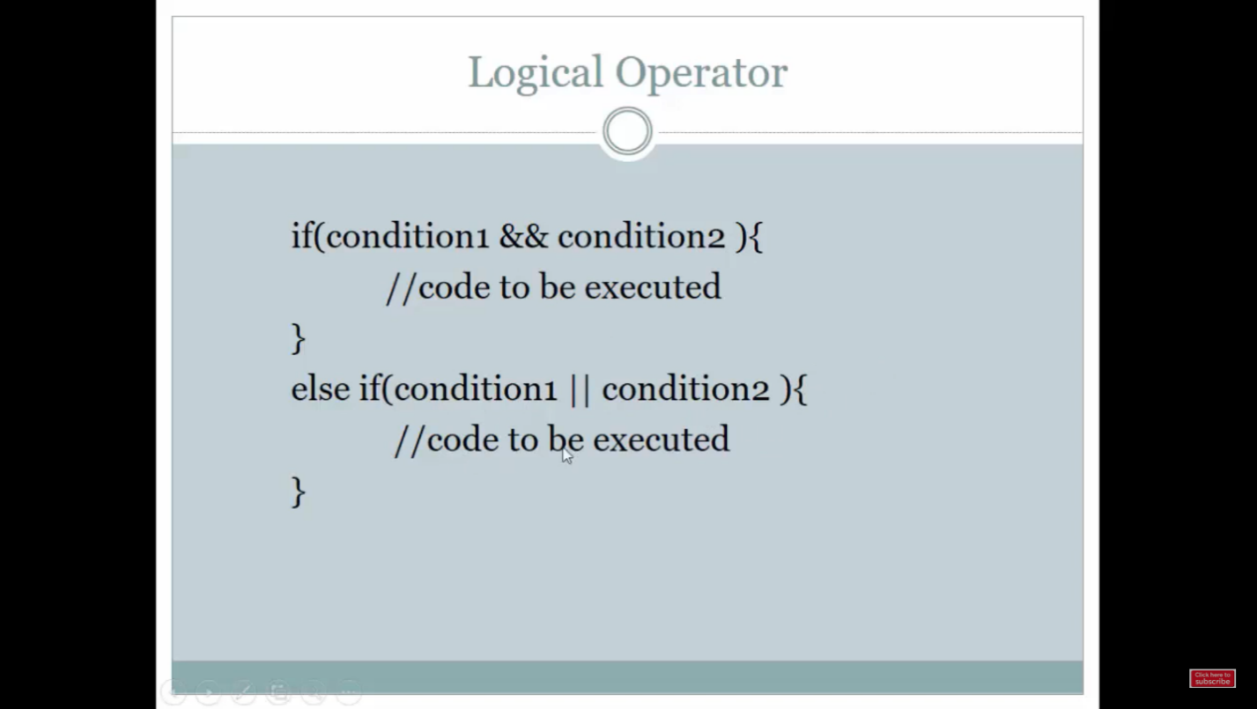

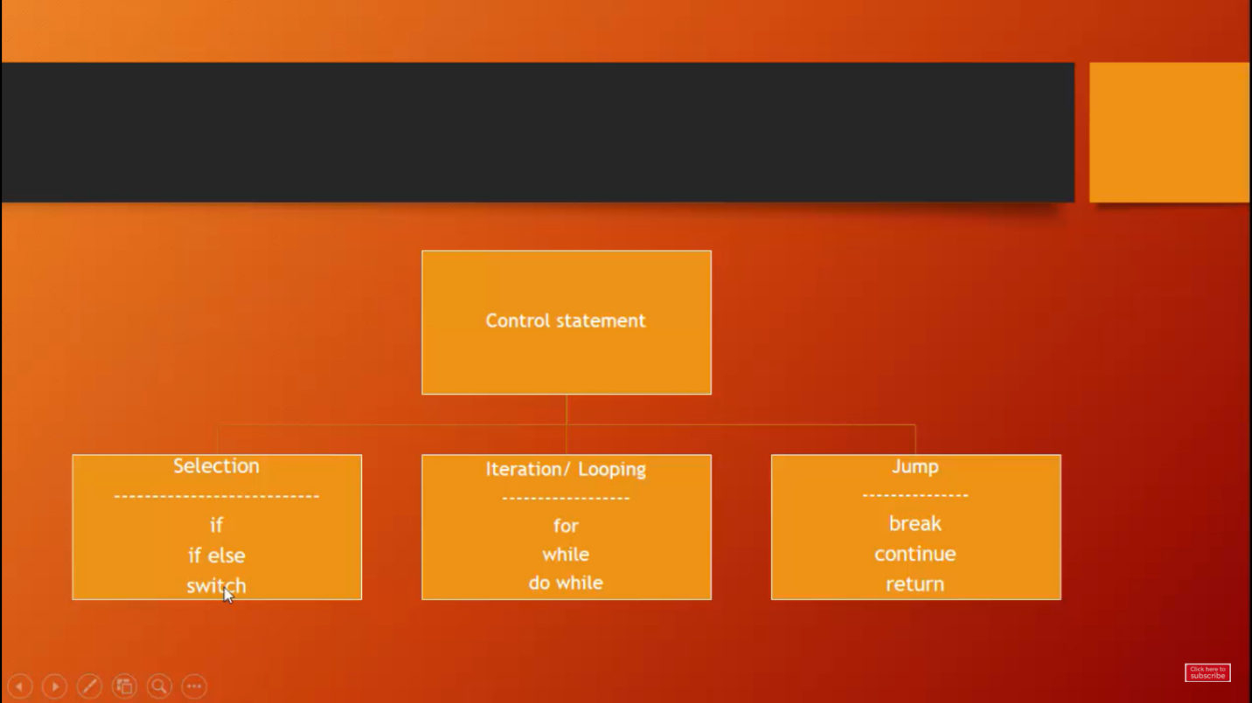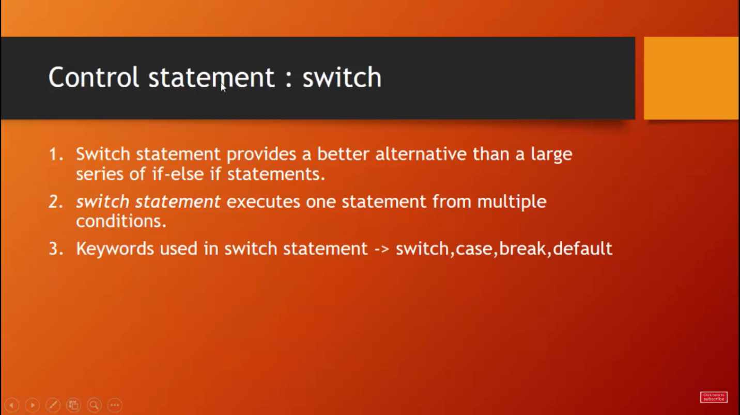

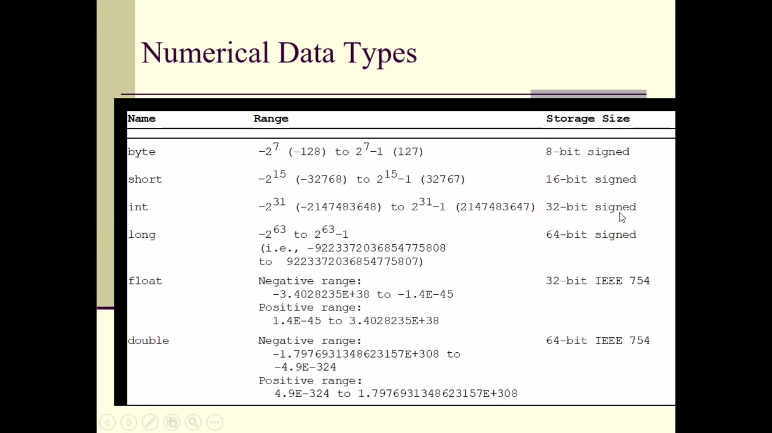

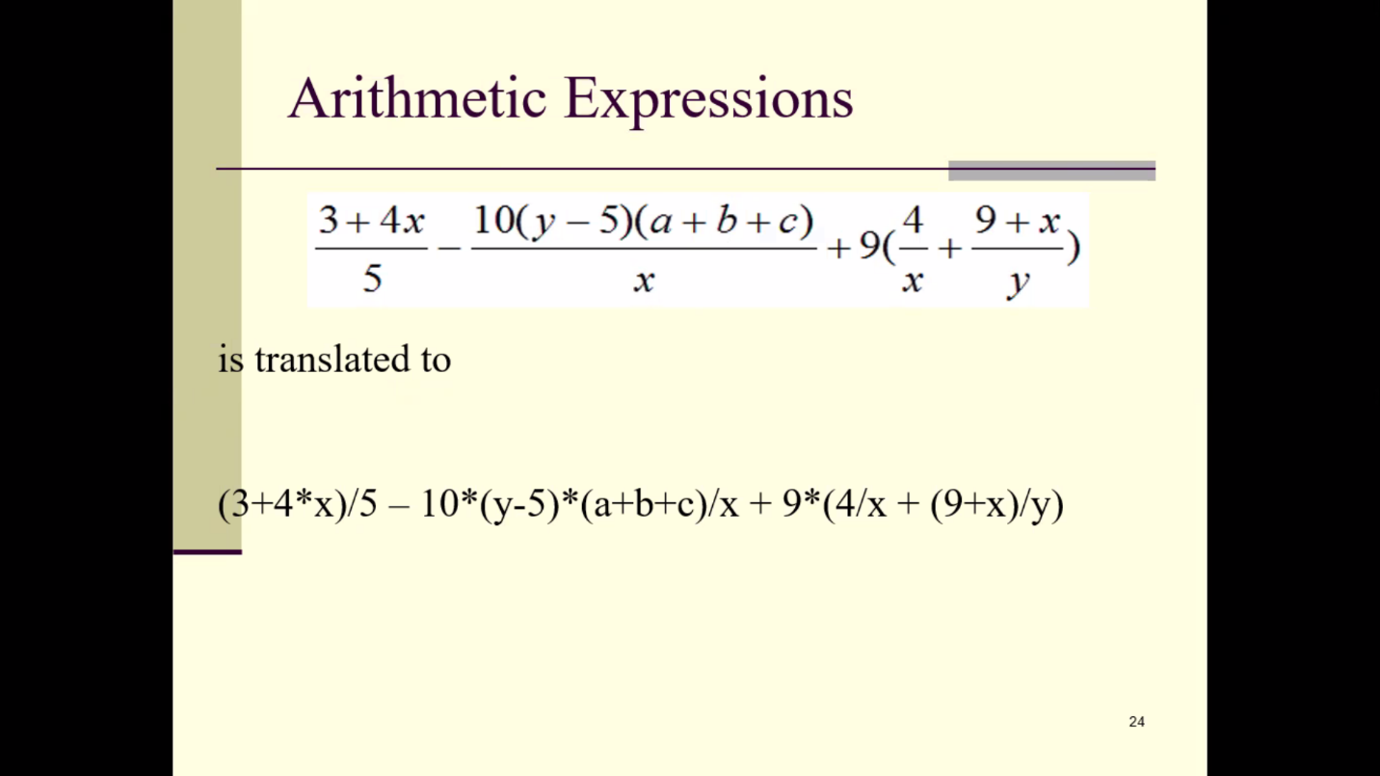

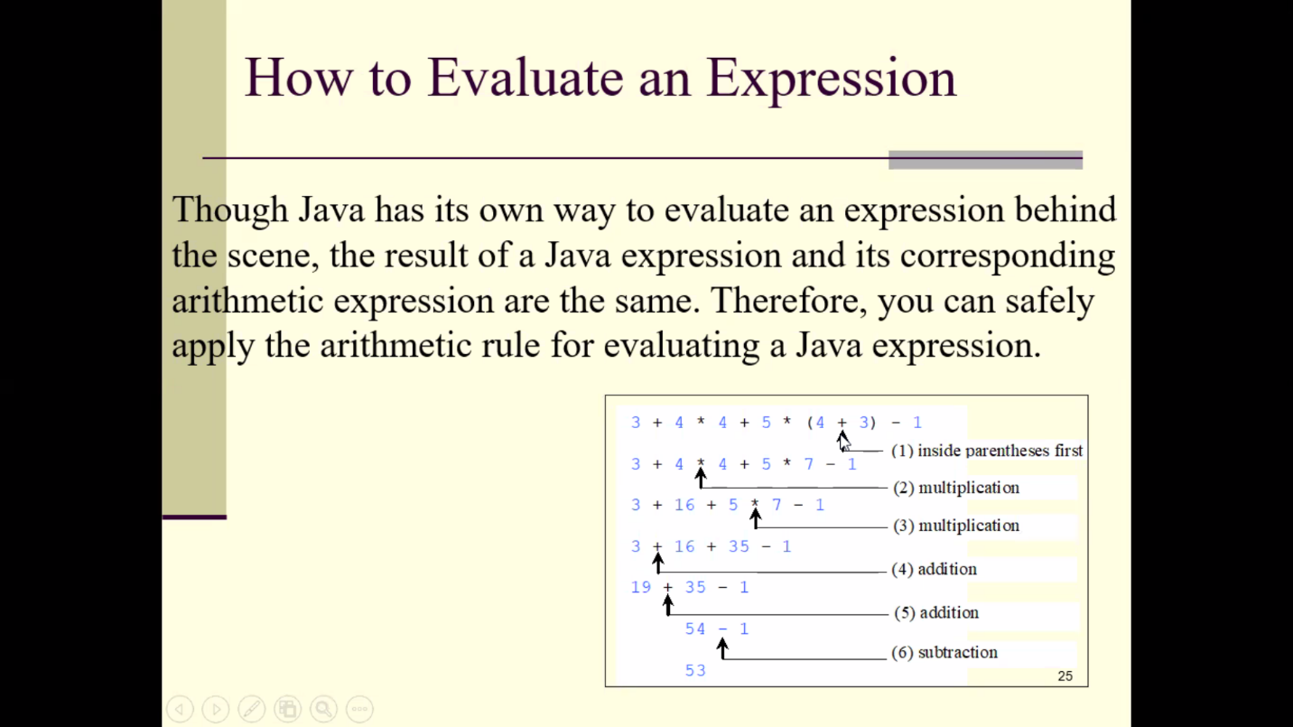

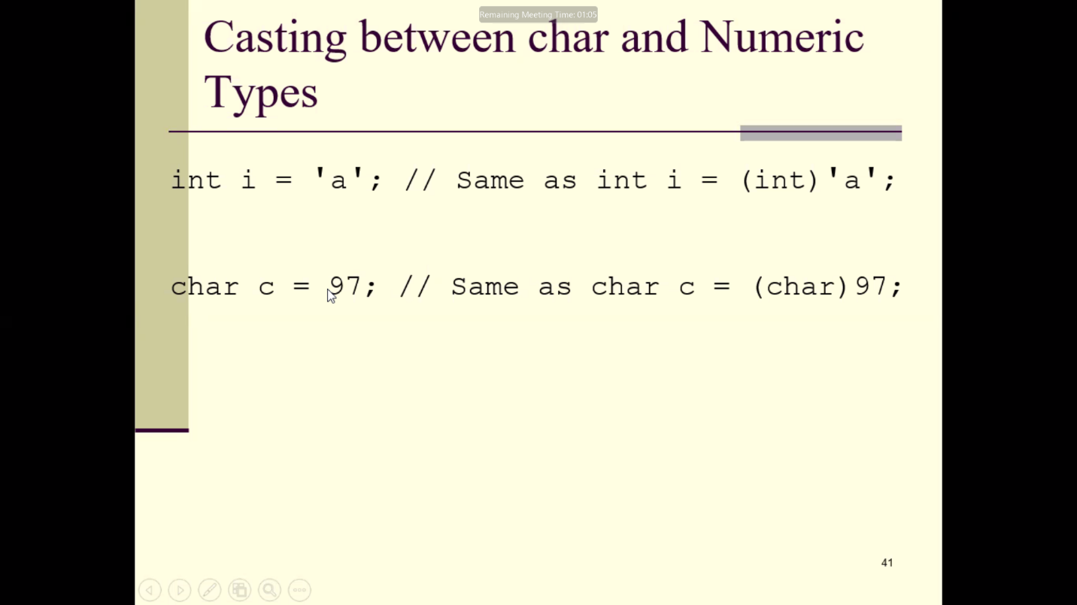

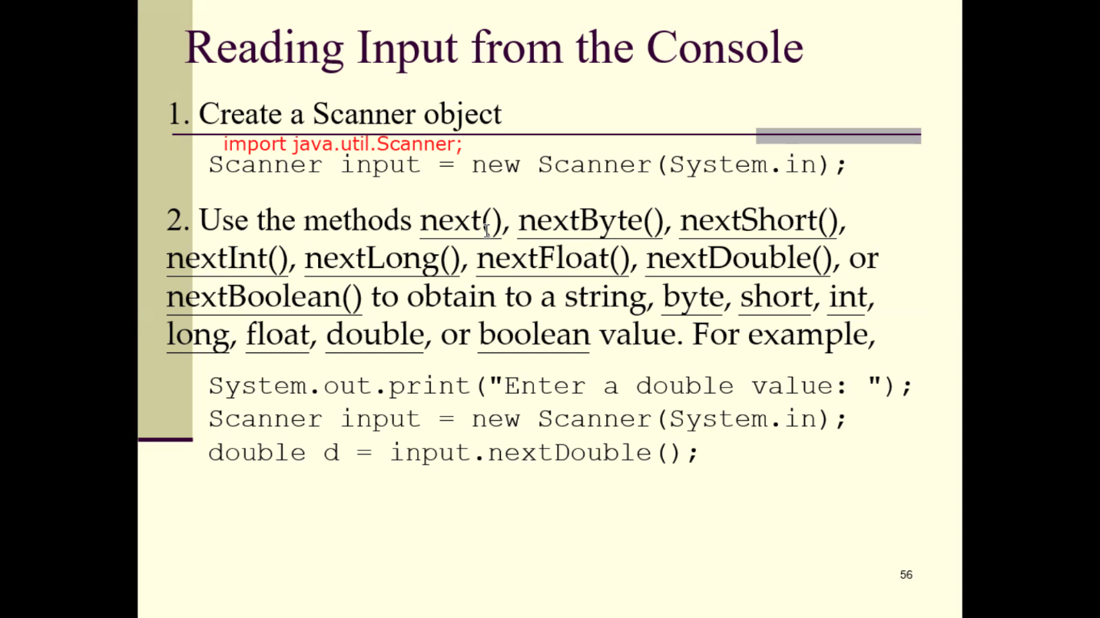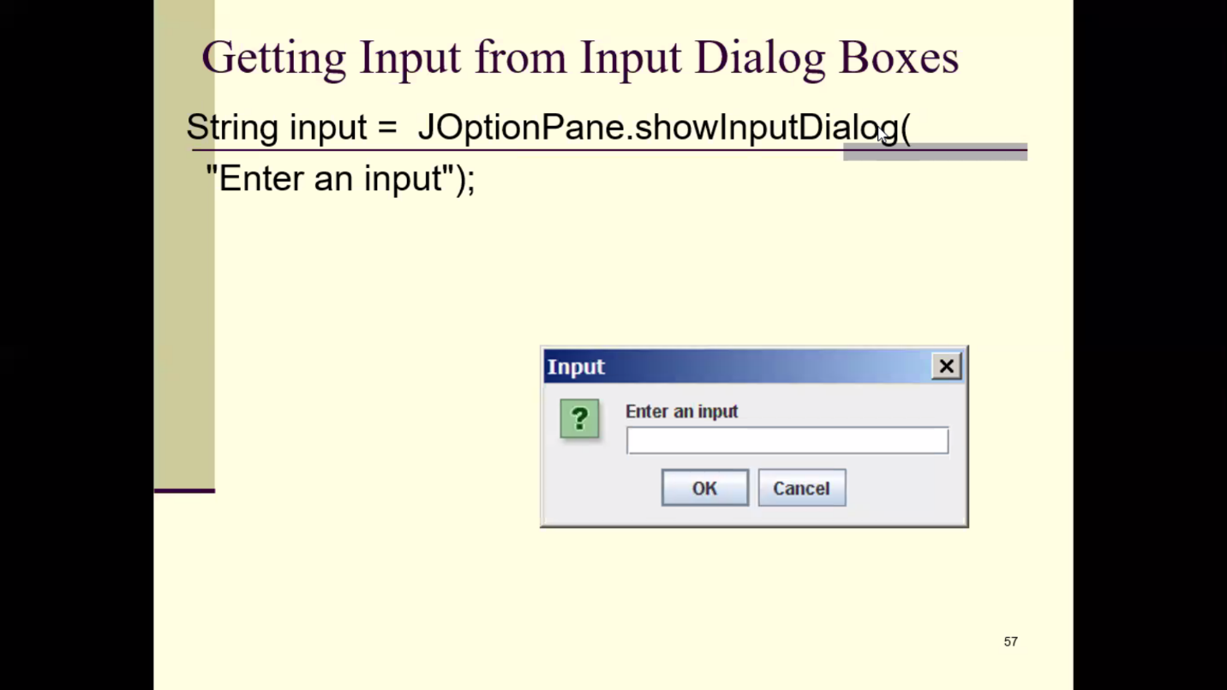

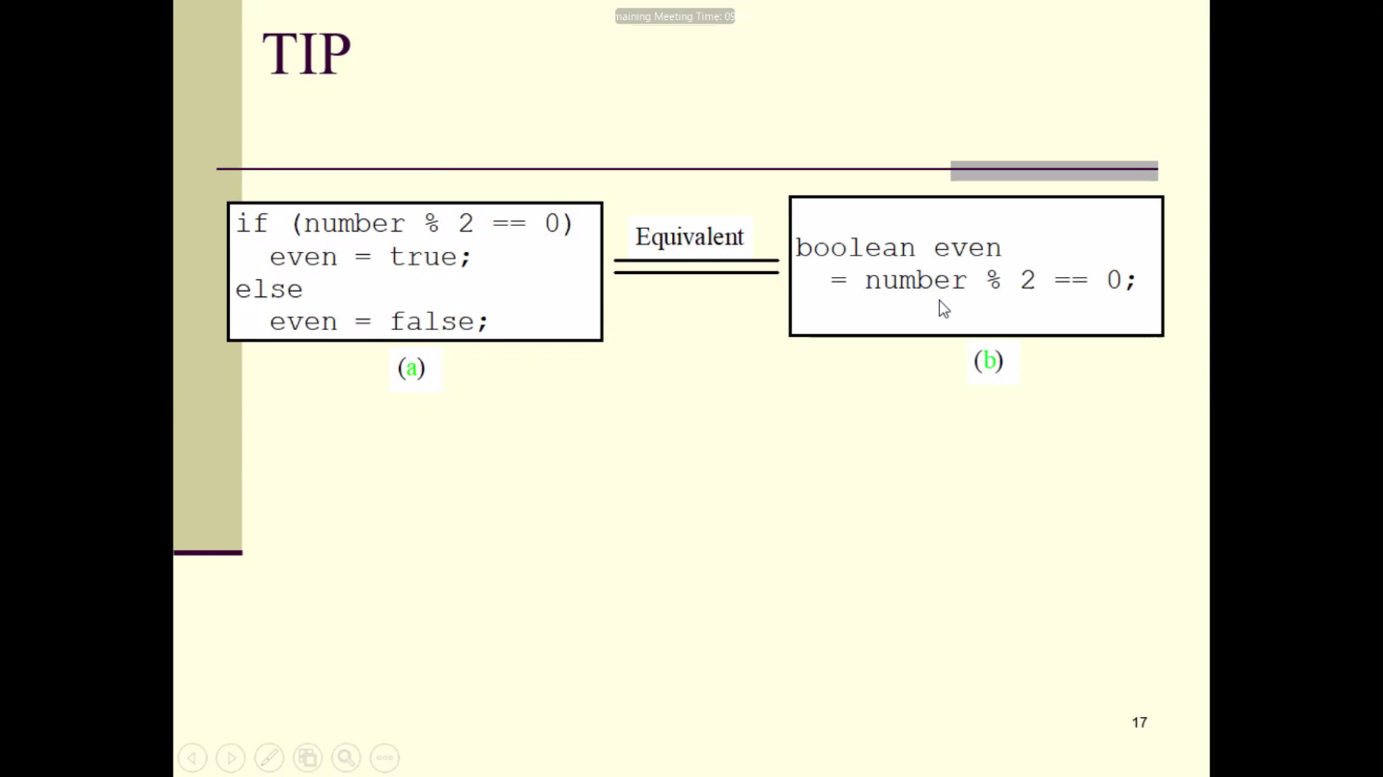

* Biodata

package basicjava;

public class BioData {

public static void main(String[] args){

System.out.println("Nizam Chowdhury \n01682872654 \nBSc in CSE\n");

System.out.println("1 \t 2");

System.out.println("3 \t 4");

System.out.println("\"Java programming\"");

}

}

* Comment Demo

package basicjava;

public class CommentDemo {

public static void main(String[] args){

System.out.println("Nizam Chowdhury"); //displaying my name

/* multiline comment */

}

}

* Execution Steps

package executionsteps;

public class ExecutionSteps {

public static void main(String[] args) {

System.out.println("Irin Akhi");

}

}

* Data Types

package datatype;

public class DataType {

public static void main(String[] args) {

boolean b = true; //dynamic initialization

char c = 'a';

short s = 32677;

int i = 126587;

float f = 10.2f;

double d =10.2;

System.out.printf("boolean b = %b \n",b);

System.out.println("charecter c = "+c);

System.out.println("short s = "+s);

System.out.println("integer i = "+i);

System.out.println("float f = "+f);

System.out.println("double d = "+d);

}

}

* Input Demo

package beginnerjava;

import java.util.Scanner;

public class InputDemo {

public static void main(String[] args) {

Scanner input = new Scanner(System.in);

int number;

String name;

double num1;

System.out.print("Enter your name : ");

name = input.nextLine();

System.out.print("Enter any double value : ");

num1 = input.nextDouble();

System.out.print("Enter your ID number :C");

number = input.nextInt();

System.out.println("Welcome : "+name);

System.out.println("CGPA = "+num1);

System.out.println("ID :C"+number);

}

}

* Arithmetic Demo

package beginnerjava;

public class ArithmeticDemo {

public static void main(String[] args) {

int num1, num2, result;

num1 = 20;

num2 = 10;

result = num1 + num2;

System.out.println("Sum = " + result);

result = num1 - num2;

System.out.println("Sub = " + result);

result = num1 * num2;

System.out.println("Mul = " + result);

result = num1 / num2;

System.out.println("Div = " + result);

result = num1 % num2;

System.out.println("Remainder = " + result);

}

}

* Arithmetic WithInput

package beginnerjava;

import java.util.Scanner;

public class ArithmeticDemo {

public static void main(String[] args) {

Scanner input = new Scanner(System.in);

int num1, num2, result;

System.out.print("Enter First Number : ");

num1 = input.nextInt();

System.out.print("Enter Second Number : ");

num2 = input.nextInt();

result = num1 + num2;

System.out.println("Sum = " + result);

result = num1 - num2;

System.out.println("Sub = " + result);

result = num1 * num2;

System.out.println("Mul = " + result);

double result2 = (double) num1 / num2;

System.out.println("Div = " + result2);

result = num1 % num2;

System.out.println("Remainder = " + result);

}

}

* Assignment Oparetor

package beginnerjava;

public class AssignmentDemo {

public static void main(String[] args) {

int x = 3;

int y = 2;

x += y; //x = x + y = 5

System.out.println(" x = " + x);

x -= y; //x = x - y = 3

System.out.println(" x = " + x);

x *= y; //x = x * y = 6

System.out.println(" x = " + x);

x /= y; //x = x / y = 3

System.out.println(" x = " + x);

x %= y; //x = x % y = 1

System.out.println(" x = " + x);

}

}

* Area Of Triangle

package beginnerjava;

import java.util.Scanner;

public class TriangleDemo {

public static void main(String[] args) {

Scanner input = new Scanner(System.in);

double base, height, area;

System.out.print("Enter base : ");

base = input.nextDouble();

System.out.print("Enter height : ");

height = input.nextDouble();

area = 0.5 * base * height;

System.out.println("Area of triangle : " + area);

}

}

* Area Of Circle

package beginnerjava;

import java.util.Scanner;

public class CircleDemo {

public static void main(String[] args) {

Scanner input = new Scanner(System.in);

double radius, area;

System.out.print("Enter radius : ");

radius = input.nextDouble();

area = 3.1416 * radius * radius;

System.out.println("Area of circle : " + area);

}

}

* Celsius To Farenheit

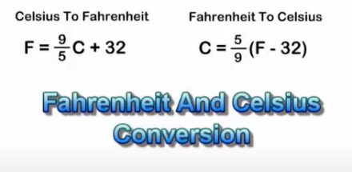

package beginnerjava;

import java.util.Scanner;

public class TemperatureDemo {

public static void main(String[] args) {

Scanner input = new Scanner(System.in);

double cels,faren;

System.out.print("Enter Celsius = ");

cels = input.nextDouble();

faren = 1.8 * cels + 32;

System.out.println("Farenheit = "+faren);

}

}

* Unary Demo

package beginnerjava;

public class UneryDemo {

public static void main(String[] args) {

int x = -10;

int result;

result = +x;

System.out.println("Result = "+result);

result = -x;

System.out.println("Result = "+result);

}

}

* Increment Decrement

package beginnerjava;

public class IncrementDecrement {

public static void main(String[] args) {

int x = 25;

int y;

y = x++; //post increment

System.out.println("y = "+y);

y = x;

System.out.println("y = "+y);

int a = 25;

int b;

b = ++a; //pre increment

System.out.println("b = "+b);

b = a;

System.out.println("b = "+b);

int p = 25;

int q;

q = p--; //post decrement

System.out.println("q = "+q);

q = p;

System.out.println("q = "+q);

int m = 25;

int n;

n = --m; //pre decrement

System.out.println("n = "+n);

n = m;

System.out.println("n = "+n);

}

}

* Control Statement (if, else)

package beginnerjava;

import java.util.Scanner;

public class IfelseDemo {

public static void main(String[] args) {

Scanner input = new Scanner(System.in);

int num;

System.out.println("Enter any integer number : ");

num = input.nextInt();

if (num > 0) {

System.out.println("Positive");

} else if (num < 0) {

System.out.println("Negative");

} else {

System.out.println("Zero");

}

}

}

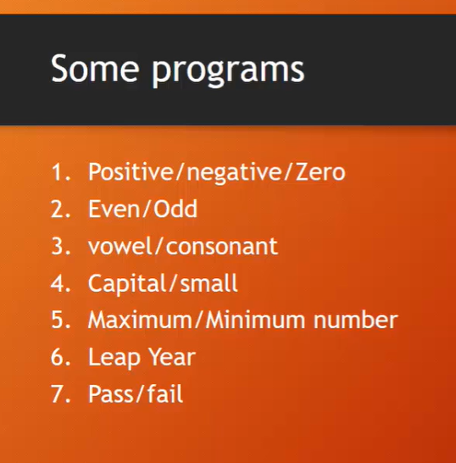

* Even Odd

package beginnerjava;

import java.util.Scanner;

public class EvenOddDemo {

public static void main(String[] args) {

Scanner input = new Scanner(System.in);

int num;

System.out.print("Enter a positive integer to check Even or Odd : ");

num = input.nextInt();

if (num % 2 == 0) {

System.out.println("Even");

} else {

System.out.println("Odd");

}

}

}

* Vowel Consonant

package beginnerjava;

import java.util.Scanner;

public class VowelConsonant {

public static void main(String[] args) {

Scanner input = new Scanner(System.in);

char ch;

System.out.println("Enter any latter : ");

ch = input.next().charAt(0);

if (ch == 'a') {

System.out.println("Vowel.");

} else if (ch == 'e') {

System.out.println("Vowel.");

} else if (ch == 'i') {

System.out.println("Vowel.");

} else if (ch == 'o') {

System.out.println("Vowel.");

} else if (ch == 'u') {

System.out.println("Vowel.");

} else {

System.out.println("Consonant.");

}

}

}

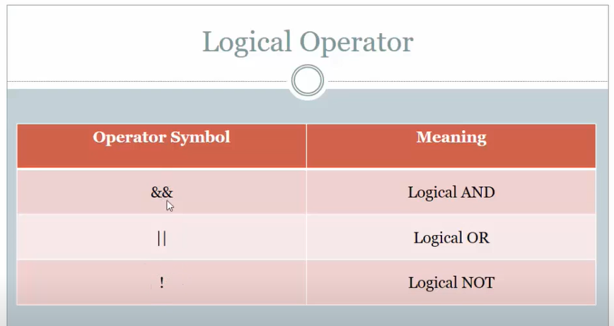

* Vowel Consonant with operator

package beginnerjava;

import java.util.Scanner;

public class VowelConsonantOp {

public static void main(String[] args) {

Scanner input = new Scanner(System.in);

char ch;

System.out.print("Enter any alphabet : ");

ch = input.next().charAt(0);

if (ch == 'a' || ch == 'e' || ch == 'i' || ch == 'o' || ch == 'u') {

System.out.println("Vowel.");

} else {

System.out.println("Consonant");

}

}

}

* Capital Small with && operator

package beginnerjava;

import java.util.Scanner;

public class CapitalSmall {

public static void main(String[] args) {

Scanner input = new Scanner(System.in);

char ch;

System.out.print("Enter any latter : ");

ch = input.next().charAt(0);

if (ch >= 'a' && ch <= 'z') {

System.out.println("Small.");

}

else if (ch >= 'A' && ch <= 'Z') {

System.out.println("Capital.");

}

else {

System.out.println("Not a latter!");

}

}

}

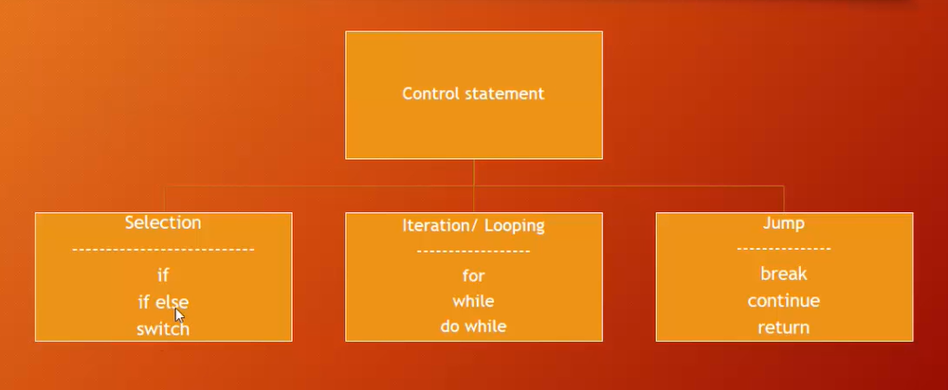

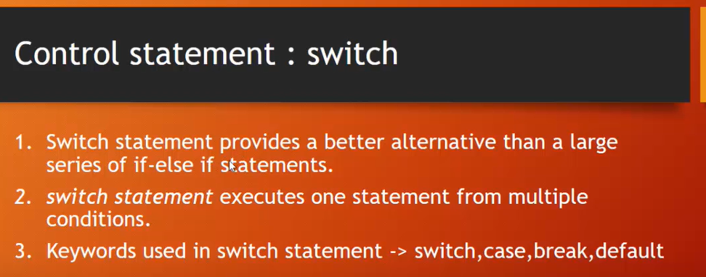

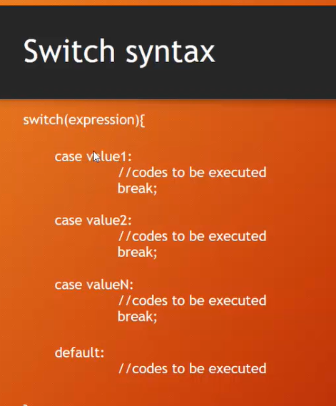

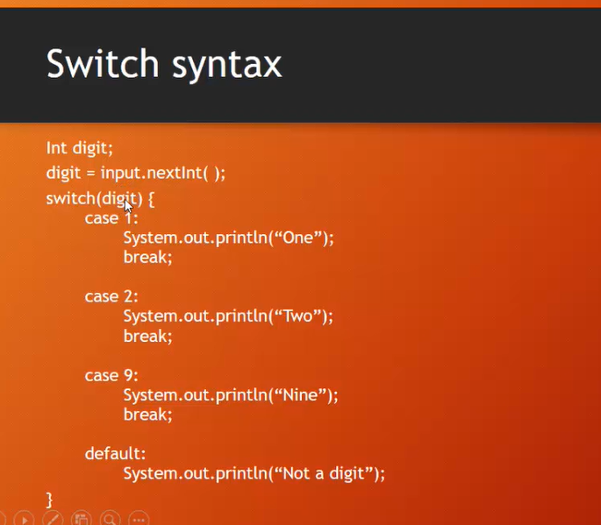

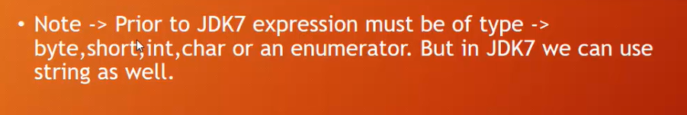

* Digit Spell by Switch(case,break,default)

package beginnerjava;

import java.util.Scanner;

public class DigitSpellingByCase {

public static void main(String[] args) {

Scanner input = new Scanner(System.in);

System.out.print("Enter any digit to spell : ");

int digit;

digit = input.nextInt();

switch(digit) {

case 0:

System.out.println("Zero.");

break;

case 1:

System.out.println("One.");

break;

case 2:

System.out.println("Two.");

break;

case 3:

System.out.println("Three.");

break;

case 4:

System.out.println("Four.");

break;

case 5:

System.out.println("Five.");

break;

case 6:

System.out.println("Six.");

break;

case 7:

System.out.println("Seven.");

break;

case 8:

System.out.println("Eight.");

break;

case 9:

System.out.println("Nine.");

break;

default:

System.out.println("Not a digit!");

}

}

}

* ConditionalOperator

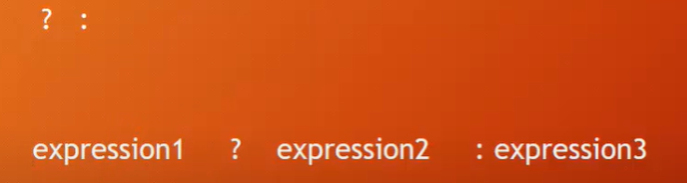

If expression1’s Statement is true then expression2 will execute.

If expression1’s Statement is false then expression3 will execute.

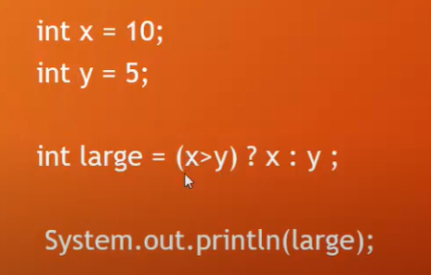

* Check Large Number

package beginnerjava;

import java.util.Scanner;

public class ConditionalDemo {

public static void main(String[] args) {

Scanner input = new Scanner(System.in);

int num1, num2, large;

System.out.print("Enter Two Numbers To Check Small or Large : ");

num1 = input.nextInt();

num2 = input.nextInt();

large = (num1 > num2) ? num1 : num2;

System.out.println("Large Number : " + large);

}

}

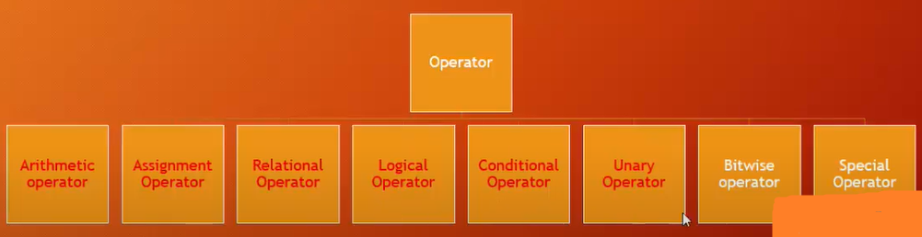

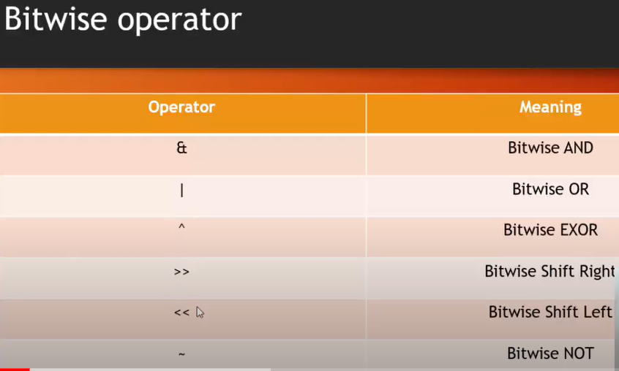

Bitwise operator works for binary numbers.

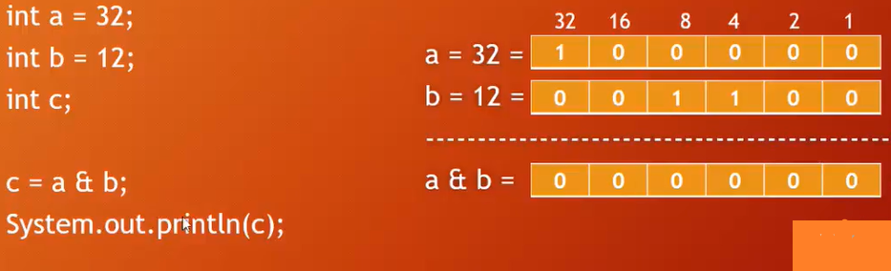

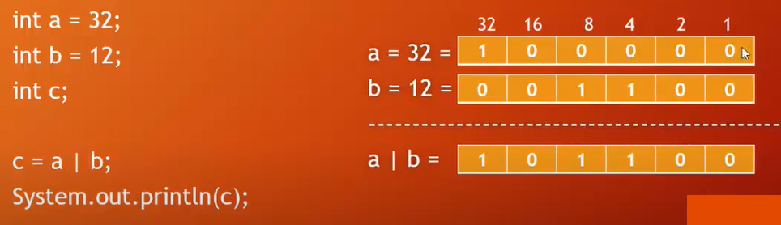

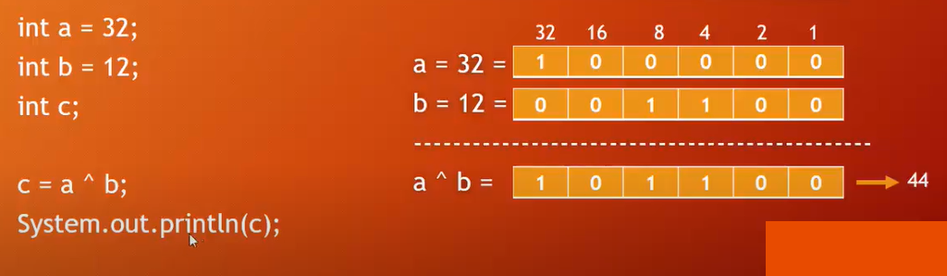

* **Bitwise Operator**

package beginnerjava;

public class BitwiseOperator {

public static void main(String[] args) {

int a = 32;

int b = 12;

int c = a & b;

System.out.println("a & b = " + c);

c = a | b;

System.out.println("a | b = " + c);

c = a ^ b;

System.out.println("a ^ b = " + c);

c = a >> 3;

System.out.println("a >> 3 = " + c);

c = a << 3;

System.out.println("a << 3 = " + c);

}

}

* **Math Class**

package beginnerjava;

public class MathClass {

public static void main(String[] args) {

int x =2;

int y =3;

int c =-6;

//OR : System.out.println(Math.max(x, y));

//math class java (google>oracle)

int max = Math.max(x, y);

System.out.println("Maximum = "+max);

int min = Math.min(x, y);

System.out.println("Minimum = "+min);

int absolute = Math.abs(c);

System.out.println("Absolute = "+absolute);

double power = Math.pow(x,y);

System.out.println("x to the power y = "+power);

int round = Math.round(8.5f);

System.out.println("Round of 8.5 = "+round);

double floor = Math.floor(8.5f);

System.out.println("Floor of 8.5 = "+floor);

double pi = Math.PI;

System.out.println("Pi = "+pi);

}

}

* **Series Multiplication**

package beginnerjava;

import java.util.Scanner;

public class SeriesMultiple {

public static void main(String[] args) {

Scanner input = new Scanner(System.in);

int n, result =1;

System.out.print("Enter the last number : ");

n = input.nextInt();

for(int i = 1; i<=n; i=i+2){

System.out.print(i+" * ");

result = result *i;

}

System.out.print(" = "+result);

System.out.println();

}

}

* **Factorial**

package beginnerjava;

import java.util.Scanner;

public class Factorial {

public static void main(String[] args) {

Scanner input = new Scanner(System.in);

int num, fact = 1;

System.out.print("Enter any positive integer : ");

num = input.nextInt();

for(int i = num; i >= 1; i--){

fact = fact * i;

}

System.out.println("Factorial of "+num+" = "+fact );

}

}

* **Multiplication Table**

package beginnerjava;

import java.util.Scanner;

public class MultiplicationTable {

public static void main(String[] args) {

Scanner input = new Scanner(System.in);

int m, n;

System.out.print("Enter Initial number : ");

m = input.nextInt();

System.out.print("Enter Final number : ");

n = input.nextInt();

System.out.println();

for (int i = m; i <= n; i++) {

System.out.println("Multiplicationt Table of " + i + " is below :");

for (int j = 1; j <= 10; j++) {

System.out.println(i + " X " + j + " = " + i * j);

}

System.out.println("\n\n");

}

}

}

* **Prime Number**

package beginnerjava;

import java.util.Scanner;

public class PrimeNumber {

public static void main(String[] args) {

Scanner input = new Scanner(System.in);

System.out.print("Enter any positive integer : ");

int num = input.nextInt();

int count = 0;

for (int i = 2; i < num; i++) {

if (num % i == 0) {

count++;

break;

}

}

if (count == 0) {

System.out.println("Prime Number ");

} else {

System.out.println("Not Prime!");

}

}

}

* **Prime Number M to N**

package beginnerjava;

import java.util.Scanner;

public class PrimeMtoN {

public static void main(String[] args) {

int m, n, count = 0, totalPrime = 0;

Scanner input = new Scanner(System.in);

System.out.print("Enter initial number : ");

m = input.nextInt();

System.out.print("Enter ending number : ");

n = input.nextInt();

for (int i = m; i <= n; i++) {

for (int j = 2; j <= i - 1; j++) {

if (i % j == 0) {

count++;

break;

}

}

if (count == 0) {

System.out.println(i);

totalPrime++;

}

count = 0;

}

System.out.println("Total prime number = " + totalPrime);

}

}